CURRENT AFFAIRS= 17-09-2020

WORLD PATIENT SAFETY DAY 2020
The World Patient Safety Day 2020 is being observed on 17 September under the theme "Health Worker Safety: A Priority for Patient Safety."
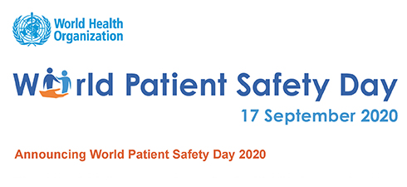
About:
- The 72nd World Health Assembly adopted resolution WHA 72.6 ‘Global action on patient safety’ on 25 May 2019.
- The resolution recognizes patient safety as a global health priority and endorses the establishment of World Patient Safety Day to be observed annually on 17 September.
- World Patient Safety Day calls for global solidarity and concerted action by all countries and international partners to improve patient safety.

KAPILA VATSYAYAN
Leading scholar of Indian classical dance, art, architecture and art history, Dr Kapila Vatsyayan passed away.
About:
- Kapila Vatsyayan (1928 – 2020) was a former Member of Parliament and also served as Secretary to the Government in the Ministry of Education, where she was responsible for the establishment of a large number of national institutions of higher education.
- She served as the founding Director of the Indira Gandhi National Centre for the Arts.
- She was former President of India International Centre (IIC) and an IIC Life Trustee and the Chairperson of the IIC International Research Division.

SALARY, ALLOWANCES AND PENSION OF MEMBERS OF PARLIAMENT (AMENDMENT) BILL, 2020
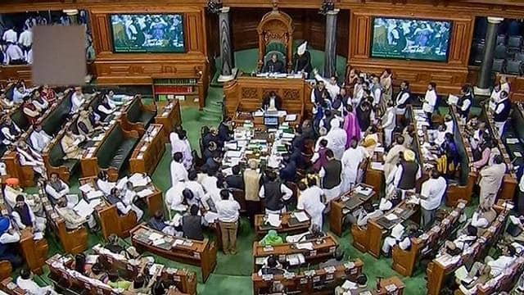
Lok Sabha unanimously passed the Salary, Allowances and Pension of Members of Parliament (Amendment) Bill, 2020.
About:
- The Bill will replace the Salary, Allowances and Pension of Members of Parliament (Amendment) Ordinance which was promulgated in April this year.
- The Bill seeks to reduce the salaries of MPs and the sumptuary allowance of Ministers by 30 per cent. It also seeks to reduce the constituency allowance and office expenses allowance of MPs.
- The Bill makes these changes effective for a period of one year, effective from 1st April, 2020.
Important Info :
- The Salary, Allowances and Pension of Members of Parliament Act, 1954 provides for the salary, allowances and pension of Members of Parliament.
- The act is in pursuance to the constitutional provisions where article 106 of the Constitution of India provides that the members of either House of Parliament shall be entitled to receive such salaries and allowances as may from time to time be determined by Parliament by law.
KOSI RAIL MAHASETU
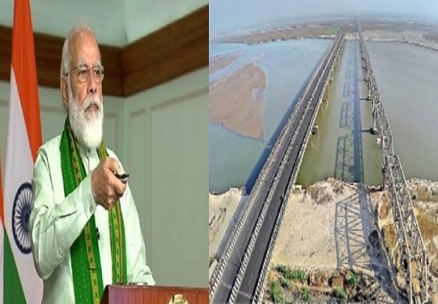
- The Prime Minister Narendra Modi shall dedicate to the nation the historic Kosi Rail Mahasetu (mega bridge) to the Nation on the 18th of September 2020. The Kosi Rail Mahasetu is 1.9 KM long.
- Background:
  - In 1887, a meter gauge link was built in between Nirmali and Bhaptiahi (Saraigarh).
  - During the heavy flood and severe Indo Nepal earthquake in 1934, the rail link was washed away and thereafter due to meandering nature of river Kosi no attempt was made to restore this Rail link for long period.
  - The Kosi Mega Bridge line project was sanctioned by Government of India during 2003-0
This bridge is of strategic importance along the India-Nepal border.

DJIBOUTI CODE OF CONDUCT/ JEDDAH AMENDMENT (DCOC/JA)
India has joined the Djibouti Code of Conduct/ Jeddah Amendment, DCOC/JA, as Observer.
- DCOC/JA is a grouping on maritime matters comprising 18 member states adjoining the Red Sea, Gulf of Aden, the East Coast of Africa and Island countries in the Indian Ocean Region.
- The DCOC, established in January 2009, is aimed at repression of piracy and armed robbery against ships in the Western Indian Ocean Region, the Gulf of Aden and the Red Sea.India has joined Japan, Norway, the UK and the US as Observers to the DCOC/JA.

SOLAR CYCLE 25
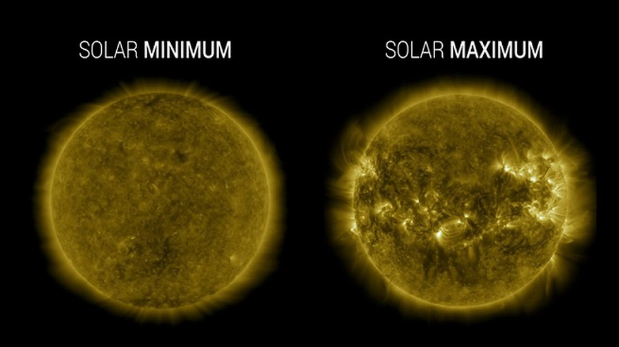
Scientists from NASA and the National Oceanic and Atmospheric Administration (NOAA) announced their predictions about the new solar cycle, called Solar Cycle 25, which they believe has begun.
What is a solar cycle?
- Since the Sun’s surface is a very active space, electrically charged gases on its surface generate areas of powerful magnetic forces, which are called magnetic fields.
- Since the gases on the Sun’s surface are constantly moving, these magnetic fields can get stretched, twisted and tangled creating motion on the surface, which is referred to as solar activity.
- Solar activity varied with the stages of the solar cycle, which lasts on average for a period of 11 years. Solar cycles have implications for life and technology on Earth as well as astronauts in space.

