Current Affairs:03.08.2021

NPCI launches digital payment solution e-RUPI
National Payments Corporation of India (NPCI) has launched an innovative digital solution – ‘e-RUPI’ in association with the Department of Financial Services (DFS), National Health Authority (NHA), Ministry of Health and Family Welfare (MoHFW), and partner banks.e-RUPI is a type of payment voucher with a one-time payment mechanism. It is built on the UPI platform.Government or Corporate entities would create e-RUPI vouchers through their partner banks and share this e-RUPI with the beneficiaries for a specific purpose or activity via SMS or QR code. The beneficiaries will be identified using their mobile numbers.

SBI launches ‘SIM Binding’ feature for YONO and YONO Lite
India’s largest lender State Bank of India (SBI) has launched a new and enhanced security feature for its YONO and YONO Lite apps, called ‘SIM Binding’, to protect customers from various digital frauds. Under the new SIM Binding feature, the YONO and YONO Lite apps will work only on those devices which have SIM of mobile numbers registered with the Bank.The main aim of the new version of the platform is to provide enhanced security to customers and help them with convenient and safe online banking experience.

Novelist Kunal Basu to release his new book ‘In An Ideal World’ in 2022
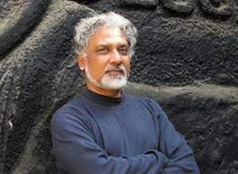
Renowned Indian author of English fiction, Kunal Basu has announced his new novel titled ‘In An Ideal World’.The novel is expected to release in early 2022, and published by Penguin Random House India.‘In An Ideal World’ is a powerful, gritty and fast-paced literary novel with a variety of themes like college, politics, family, crime investigation and fanaticism.

Nikol Pashinyan Re-appointed as Prime Minister of Armenia
Nikol Pashinyan has been re-appointed as the prime minister of Armenia by the President Armen Sarkissian on August 02, 2021.Pashinyan, the leader of the Civil Contract Party, won majority of seats in parliamentary elections in June 2021.The 46 year old Pashinyan was first appointed as the prime minister in 2018.

Myanmar Military Chief appointed as interim Prime Minister
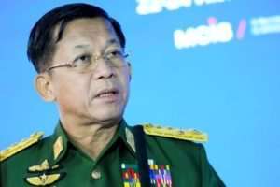
The Chief of the Myanmar military, Senior General Min Aung Hlaing has taken over as the interim prime minister of the country on August 01, 2021.Hlaing is also the Chairman of the State Administration Council (SAC) which has been performing the duties of the government in Myanmar, after February 01, 2021 coup, which overthrew Aung San Suu Kyi’s ruling party. This SAC has been reformed as caretaker government of Myanmar in order to perform the country’s duties fast, easily and effectively.

Centenarian Sprinter Man Kaur passes away at 105
Multiple World Masters Athletics Championship gold medallist, Man Kaur, has passed away. She was 105.The Centenarian sprinter from Patiala, Punjab, started as an athlete at the age of 93.

