Current Affairs : 03 June 2022

ANJALAI PONNUSAMY
The Prime Minister, Shri Narendra Modi has condoled the passing away of the distinguished INA Veteran from Malaysia Anjalai Ponnusamy.
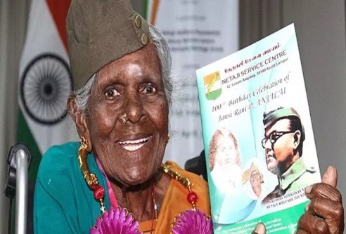
About:
- Anjalai was once a soldier who served under the command of Netaji Bose, who led the Indian National Army in 1943.
- At the age of 21, Anjalai joined the Rani of Jhansi Regiment – the women’s regiment of the Indian National Army.
- After the war ended with the Japanese defeat, the Indian National Army was disbanded, and Anjalai returned home to continue her life in Malaysia.

AIRBAGS
Maruti Suzuki, India’s top carmaker, wants the government to review a proposal to make six airbags mandatory in passenger vehicles, citing its impact on the price-sensitive entry-level car segment.
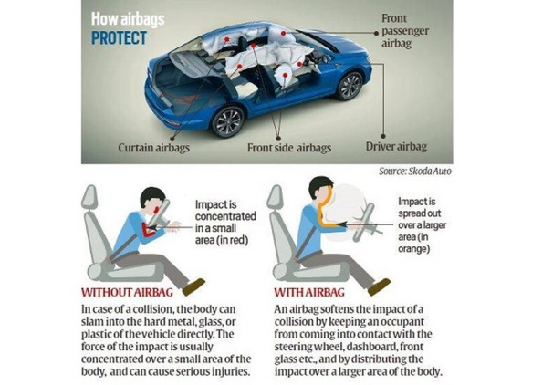
- Airbags soften the impact of collisions by keeping occupants from coming into contact with the steering wheel, dashboard, front glass, and other parts of the automobile.
- In January 2022, Union Road Transport Minister said that “In order to enhance the safety of the occupants in motor vehicles carrying upto 8 passengers, I have now approved a Draft GSR Notification to make a minimum of 6 Airbags compulsory.” No timelines were mentioned then.
- Dual airbags (driver and passenger) became mandatory on all vehicles this January. A driver airbag has been compulsory for all passenger vehicles since July 1, 2019.
- Additional airbags are proposed in the ‘M1’ category of vehicles, with the aim of minimising the impact of “frontal and lateral collisions” to the occupants of both the front and rear compartments. As per the proposal, two side or side torso airbags, and two side curtain or tube airbags covering all outboard passengers, will be made mandatory.

What is an ‘M1’ vehicle?
- Under the government’s homologation rules, vehicles are bucketed into broad categories.
- ‘Category M’ covers motor vehicles with at least four wheels, used for carrying passengers.
- Sub-category ‘M1’ defines “a motor vehicle used for the carriage of passengers, comprising not more than eight seats in addition to the driver’s seat”. This category effectively subsumes the bulk of the passenger vehicles on India’s roads.
- Homologation is the process of certifying that a particular vehicle is roadworthy, and matches certain specified criteria laid down by the government for all vehicles that are built or imported into the country.

HAR GHAR DASTAK 2.0
“HarGharDastak campaign 2.0” to accelerate the pace and coverage of COVID19 vaccination across States and UTs has commenced across India by Union Health Ministry.
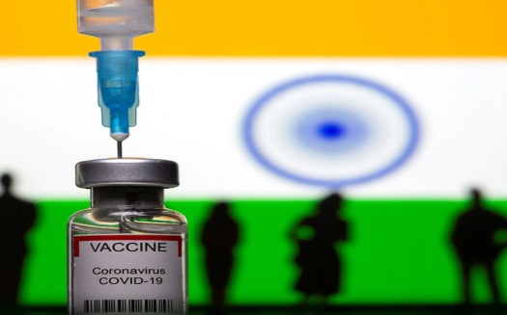
About:
- Incorporating the experience & learning from “HarGharDastak campaign” launched in Nov 2021, ‘HarGharDastak 2.0’ will be implemented from 1st June 2022 to 31st July 2022.
- The objective of the ‘Har GharDastak2.0’ Abhiyan is to vaccinate and cover the eligible population groups for first, second and precaution doses through door-to-door campaigns.
- Major focus will also remain on improving sub-optimal coverage of persons aged ≥ 60years with precaution dose, along with considerably slower speed of coverage in the 12-14 years cohort.
- The ‘Har Ghar Dastak’ Teekakaran Abhiyaan has been inspired by the successful strategy of Mission Indradhanush.

INDIA – ISRAEL DEFENCE TIES
India and Israel signed a ‘vision Statement’ to deepen the long-standing defence cooperation. This was adopted at a meeting between Defence Minister Rajnath Singh and his visiting Israeli counterpart Benny Gantz.
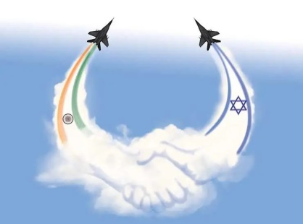
About:
- The two Ministers presented a joint declaration marking 30 years of Israel-India relations and reiterated their commitment to deepening defence ties.
- They discussed partnerships within the government-to-government framework, military training, and technological cooperation with a focus on Unmanned Aerial Vehicles (UAV) and defensive capabilities.
- A Letter of Intent on enhancing cooperation in the field of futuristic defence technologies was also exchanged between the two Ministers.
- The Ministers also discussed a cooperation agreement signed between the Indian Defence Research and Development Organisation (DRDO) and Israel’s Directorate for Defence R&D.

INDIA SENDS DIPLOMATS TO KABUL FOR TALKS WITH THE TALIBAN

- India has sent a multi-member team of senior diplomats to Afghanistan for the first time since the Indian Embassy in Kabul was evacuated in August 2021.

Significance of Afghanistan
- Economic Significance:
  - Pipeline Routes: The country is located strategically adjacent to the oil and gas rich Middle East & Central Asia.
  - India has also signed the TAPI pipeline project that aims to bring natural gas from Turkmenistan through Afghanistan and Pakistan to India.
  - Natural Resources: Afghanistan is rich in natural resources such as precious metals and minerals.

- Regional Balance of Power:
  - India needs Afghanistan to keep Pakistan in check just like China has been using Pakistan against India.

- Strategic Significance of Afghanistan:
  - Afghanistan is gateway to energy rich central Asia & situated at crossroads between South Asia & Middle East.

- For India’s Internal Security:
  - Stable government in Kabul is essential to reduce terror activities across south Asia & in J & K.
  - In the past, Pakistan-backed anti-India terrorist groups got support from the Taliban. The Kandhar Hijack of 1999 is an example of this.

India’s stand on Afghanistan after Taliban takeover
- With India in chair, UNSC adopts resolution on Taliban
  - Under India’s presidency, UNSC adopted resolution 2593.
  - It stated that the territory of Afghanistan is not to be used to threaten any country or shelter terrorists.

- Continued humanitarian aid
  - Although, India closed its embassy in Afghanistan, it continued with the humanitarian aid.
  - It was widely acclaimed by the world leaders including Taliban leaders.

India’s Contribution in Afghanistan
- India’s contribution to the development of Afghanistan includes projects in critical areas such as power, water supply, road connectivity, health care, education and agriculture.
  - Indian development ventures covered all 34 provinces of Afghanistan.
- India provided 75,000 tonnes of wheat to Afghanistan to strengthen food security during the Covid-19 pandemic.
- India was the largest regional donor to Afghanistan with pledges totalling almost $3 billion.

Background:
- After the Taliban takeover in August, 2021, in the light of the deteriorating security situation in Afghanistan, India decided to bring back all its personnel.
  - India shuttered its embassy in Kabul in August 2021 and its consulates in Herat, Kandahar, Jalalabad and Mazar-e-Sharif in the months and years before the Taliban takeover.
- India, like other countries, has not recognised the Taliban setup in Afghanistan.
- However, it is taking very cautious approach in dealing with Taliban.
  - As part of its cautious approach to the Taliban, India has been supportive of the humanitarian requirements of the Afghan people.
- Against this backdrop, the Indian delegation made the current visit.

- Team included woman official
  - The Indian team included a woman official.
  - This is being interpreted as a subtle reminder to the Taliban to ensure equitable treatment for women in Afghanistan.

Response of Taliban
- The Taliban has been hosting several international delegations from countries like Pakistan, the U.A.E., Iran, and others.
  - This is the first visit from the Indian side.
- The Taliban has specifically asked the Indian delegation to reopen its diplomatic mission in Afghanistan.

India’s recent assistance to Afghanistan
- Humanitarian assistance
  - India has dispatched several shipments of humanitarian aid consisting of 20,000 tonne of wheat, 13 tonne of medicines, 500,000 doses of Covid-19 vaccines and winter clothing.
  - India has pledged to send a total of 50,000 tonnes of wheat though deliveries.
  - These deliveries have been delayed because of complications created by Pakistani authorities while granting access to land routes for ferrying supplies.
  - The Indian consignments were handed over to the Indira Gandhi children’s hospital in Kabul and UN agencies such as the WHO and World Food Programme (WFP).

