Current Affairs : 02 June 2022

CASTE-BASED CENSUS IN BIHAR
A multi-party meeting held in Bihar unanimously decided to start the caste-based census very soon after the proposal is placed in the Cabinet.
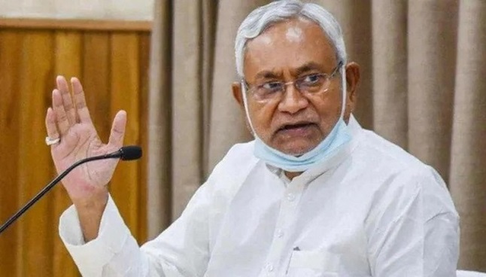
- All parties which have representation in the legislature attended the meeting, chaired by Chief Minister Nitish Kumar.
- It would be a “time-bound exercise and each and every detail of caste, sub-castes, community and religion will be taken care of for the development of all people”.
- Earlier, the Bihar Legislature passed resolutions twice for caste-based census and an 11-member all-party delegation too had met Prime Minister Narendra Modi to demand the exercise.
- However, the Central government had rejected their demand saying it would be a “divisive exercise” but said “States can hold caste census on their own”.
- Once this exercise will be over in Bihar, the other States too may follow suit and the whole nation will be covered”, the Chief Minister, Nitish Kumar, said.

CENTRAL RESERVE POLICE FORCE (CRPF)
The Union Cabinet has approved a proposal to relax the educational qualification for tribal youth from the 3 districts of Sukma, Bijapur and Dantewada in Chattisgarh for recruitment as constables in the Central Reserve Police Force (CRPF).

About:
- Minimum educational qualification will be relaxed from Class 10 to Class 8 for the recruitment of 400 candidates from the districts. CRPF would impart formal education during the probation period to these newly recruited trainees.
- CRPF during 2016-2017 had raised one Bastariya Battalion by recruiting Scheduled Tribe candidates from four districts namely, Bijapur, Dantewada, Narayanpur and Sukma of Chhattisgarh.
- However, it could not yield optimum results as native youths from interior areas could not compete in the recruitment process due to non- fulfilling of requisite educational qualification i.e. 10th pass.

WHAT IS LIQUID NANO UREA, PRODUCED BY IFFCO

- During his recent visit to Gujarat, Prime Minister Narendra Modi officially inaugurated the country’s first liquid nano urea plant at Kalol.
- This patented product is expected to not only substitute imported urea, but to also produce better results in farms.

About Fertilizers:
- A fertilizer is a chemical product either mined or manufactured, containing one or more essential plant nutrients that are immediately or potentially available in sufficiently good amounts.
- Fertilizers have played an essential role in agricultural production, providing vital nutrients for crops, increasing demands over the years.

Macro & Micro Elements in Fertilizers:
- Macro Nutrients: Nitrogen (N), Phosphorus (P), Potash (K), Calcium, Sulfur (S), and Magnesium are known as macro-nutrients (required in comparatively larger amounts).
- Micro Nutrients: Iron (Fe), Zinc (Zn), Copper, Boron, Manganese, Molybdenum, Chloride, and others are the micro-nutrients (required in a smaller quantity) for the growth and development of crop plants.
- Among the various types, NPK (nitrogen, phosphorus, and potassium) fertilizers are the most common ones, and Urea stands as the highly consumed fertilizer in India.
- India is the second-largest consumer of fertilizers globally, with an annual consumption of more than 55.0 million metric ton.

What is Liquid Nano Urea?
- Urea is a chemical nitrogen fertiliser, white in colour, which artificially provides nitrogen, a major nutrient required by plants.
- Liquid nano urea is essentially urea in the form of a nanoparticle.
- The product has been developed at IFFCO’s Nano Biotechnology Research Centre (NBRC) at Kalol.

Benefits:
- Reduced Subsidy Bill:
  - The liquid nano urea produced by Indian Farmers Fertiliser Cooperative (IFFCO) Limited comes in a half-litre bottle priced at Rs 240, and carries no burden of subsidy
  - By contrast, a farmer pays around Rs 300 for a 50-kg bag of heavily subsidised urea.
  - The government’s fertiliser subsidy pay-out this financial year will be Rs 2 lakh crore, up 25 per cent from the Rs 1.6 lakh crore it paid last year.
- Increased Efficiency:
  - Apart from reducing the country’s subsidy bill, it is aimed at reducing the unbalanced and indiscriminate use of conventional urea, increase crop productivity, and reduce soil, water, and air pollution.
  - While conventional urea has an efficiency of about 25 per cent, the efficiency of liquid nano urea can be as high as 85-90 per cent.
- Low Wastage:
  - Liquid nano urea is sprayed directly on the leaves and gets absorbed by the plant.
  - Fertilisers in nano form provide a targeted supply of nutrients to crops, as they are absorbed by the stomata, pores found on the epidermis of leaves.
  - Also, liquid nano urea has a shelf life of a year.

News Summary:
- During his recent visit to Gujarat, Prime Minister Narendra Modi officially inaugurated the country’s first liquid nano urea plant at Kalol.
- Nano Urea, made by IFFCO, has the potential to prove to be a game changer for agriculture in the country.
- India has become the first country globally to start commercial production of Nano Urea.
- Kalol plant has been set up by IFFCO with an investment of Rs 175 crore.
- Earlier, MoUs and other related agreements had been signed for technology transfer from IFFCO to public sector fertiliser companies.
  - This technology transfer is meant to ramp up the production.
- The consistent supply of nano urea will result in faster adoption and would also result in more savings to farmers and government subsidies.

NEW INSURANCE COVERS DON’T NEED IRDAI’S NOD

- The Insurance Regulatory and Development Authority of India (IRDAI) extended the “Use and File” procedure to all health insurance products, facilitating faster customer access to health policies.
- The “Use and File” procedure allows insurers to launch a product first and then file its details with the regulator.

About Insurance Regulatory and Development Authority of India (IRDAI):
- It was set up as autonomous body under the IRDA Act, 1999.

Objective: To protect the interests of policyholders, to regulate, promote and ensure orderly growth of the insurance industry and for matters connected therewith or incidental thereto.
- IRDA is the apex body that supervises and regulates the insurance sector in India.
- Nodal Ministry: Ministry of Finance

Functions:
- To have a fair regulation of the insurance industry while ensuring financial soundness of the applicable laws and regulations.
- To frame regulations periodically so that there is no ambiguity in the insurance industry.
- Registering and regulating insurance companies;
- Protecting policyholders' interests;
- Licensing and establishing norms for insurance intermediaries;
- Promoting professional organisations in insurance;
- Regulating and overseeing premium rates and terms of non-life insurance covers;
- Specifying financial reporting norms of insurance companies;
- Regulating investment of policyholders' funds by insurance companies;
- Ensuring the maintenance of solvency margin by insurance companies;
- Ensuring insurance coverage in rural areas and of vulnerable sections of society.

News Summary:
- The Insurance Regulatory and Development Authority of India (IRDAI) extended the “Use and File” procedure to all health insurance products, facilitating faster customer access to health policies.
- Until now the IRDAI required prior approval for launching products.
- The “Use and File” is a system that is used by non-life regulators globally.

Potential Benefits of “Use and File” Procedure:
- The “Use and File” procedure allows insurers to launch a product first and then file its details with the regulator.
- This helps in avoiding a longer waiting duration in offering innovative insurance solutions to customers in order to help address the dynamic environment.
- It is a proactive initiative by IRDAI which will provide some necessary mechanisms to insurance companies who wish to bring out more innovative products in the market at a faster frequency.

