Current Affairs : 01 June 2022

QUESTIONING THE SAFETY OF AADHAR
- The Unique Identification Development Authority of India (UIDAI) recently withdrew the notification which directed people to exercise “normal prudence” in sharing their Aadhaar numbers and refrain from sharing photocopies of their Aadhaar Card.

Background
- In July 2018, Telecom Regulatory of India’s Chairman tweeted his Aadhaar number challenging users to “cause him any harm”. In response, users dug up his mobile number, PAN number, photographs, residential address and date of birth.
- UIDAI dismissed assertions of any data leak, arguing that most of the data was publicly available. It did however caution users from publicly sharing their Aadhaar numbers.

About UIDAI advisory
- Masked Aadhar card: The withdrawn notice had suggested holders use a masked Aadhaar card instead of the conventional photocopy. ‘Masked Aadhaar’ veils the first eight digits of the twelvedigit ID with ‘XXXX’ characters.
- Download: The document must not be downloaded from a cybercafé or public computer and if done for some reason, must be permanently deleted from the system. ‘Masked Aadhaar’ veils the first eight digits of the twelvedigit ID with ‘XXXX’ characters.
- Collect Aadhar: The notice informed that only entities possessing a ‘User Licence’ are permitted to seek Aadhaar for authentication purposes. Private entities like hotels or film halls cannot collect or keep copies of the identification document.

What does the law say?
- Legislation: The Aadhaar (Targeted Delivery of Financial and Other Subsidies Benefits and Services) Act, 2016 makes it clear that Aadhaar authentication is necessary for availing subsidies, benefits and services that are financed from the Consolidated Fund of India.
- Definiton: Aadhaar has been described as a preferred KYC (Know Your Customer) document but not mandatory for opening bank accounts, acquiring a new SIM or school admissions.
- Consent: The requesting entity obtains the consent of the individual before collecting his/her identity and ensure that the information is only used for authentication purposes on the Central Identities Data Repository (CIDR). This centralised database contains all Aadhaar numbers and holder’s corresponding demographic and biometric information.
- Confidentiality: Additionally, the Aadhaar Act forbids sharing Core Biometric Information (such as finger print, iris scan, among other biometric attributes) for any purpose other than Aadhaar number generation and authentication.
- Publicity : Also, no Aadhaar number (or enclosed personal information) collected from the holder can be published, displayed or posted publicly.
- Disclosure: Identity information or authentication records would only be liable to be produced pursuant to an order of the High Court or Supreme Court, or by someone of the Secretary rank or above in the interest of national security.
- Alternative: In the absence of Aadhaar, the individual is to be offered an alternate and viable means of identification to ensure she/he is not deprived of the same.

Consequences of biometrics leakage
- UIDAI’s claim: The UIDAI maintains that merely knowing the bank account number would not be enough to withdraw money from the bank, stating that the individual’s fingerprint, iris data or OTP to a registered mobile number would be required.
- Stealing biometrics: A farstretch means for acquiring biometrics would involve collecting fingerprints from varied places that an individual might touch unknowingly in a certain space (such as a railing of a staircase) with iris data being acquired from highresolution cameras.
- Linking phone number: As for mobile verification, phone users in India are known to carry two or more phone numbers at one time. There could be a possibility that the number linked to the Aadhaar is not prominently used.
- Financial fraud: Fraudsters could use this as an opportunity to link their phone numbers instead, update it in the bank using the available information (of the individual) and deprive them of benefits of embezzle funds.

ISRAEL, UAE SIGN FREE TRADE DEAL, FIRST WITH AN ARAB COUNTRY

- Israel and the United Arab Emirates signed a free trade agreement, the first of its kind that Israel has concluded with an Arab country.

Israel-UAE Peace Deal
About
- In September 2020, the UAE and Israel have signed an agreement to normalise their relationship.
- The deal, known as Abraham Accord, was brokered by the United States of America.
  - After Egypt's peace treaty with Israel in 1979, followed by Jordan's in 1994, this makes the UAE only the third Arab country to normalise relations with Israel.

Key Highlights of the deal:
- The deal promises to establish normal relations between the two countries.
  - This includes business relations, tourism, direct flights, scientific cooperation, and, in time, full diplomatic ties at the ambassadorial level.
- An important component of the deal is enhanced security cooperation against regional threats, especially from Iran and its proxies.
- Israel, on its part, has agreed to suspend declaring sovereignty over territories it occupies in the West Bank.
  - It was highlighted in the Joint Statement released after the signing of peace deal.

Why this deal took place?
- Iran Factor
  - Israel insists that concerns emanating from the Iranian nuclear programme are an existential threat for the country.
  - On the other hand, the UAE has long accused Iran of playing the sectarian card to destabilise the Gulf Arab states.
  - The UAE and Iran also have a long-standing territorial dispute, with Iran’s occupation of the islands of Greater Tunb, Lesser Tunb and Abu Musa a sore issue.
  - These islands were occupied by the Shah of Iran in November 1971, just two days prior to the UAE gaining independence from Britain.

- Ambitions of UAE
  - UAE has ambitions globally, and beyond. It has just become the first Arab country to send a mission to Mars.
  - Israel is by far the most technologically advanced country in the Middle East, with cutting-edge inventions.
  - If this alliance works out it could propel the UAE to a new level of prosperity and international prestige

Significance of this deal for India
- This deal provides India an unexpected opportunity to play a bigger role in a region which is its strategic backyard.
  - India already enjoys a very good relationship with UAE and Israel.
- Keeping this in mind, India should ramp up defence and security relations with UAE.
  - Israel is already a very close defence partner.
  - India should restart joint exercises with UAE, and even Saudi Arabia.
- India can also use its good relationship to ensure that any future deal on a regional security framework gives adequate space to Iran.
- Recently, China has indicated its willingness to play a larger role in this region, and is close to both UAE and Israel and, increasingly, Saudi Arabia.
- India should make its moves before this market and this extended neighbourhood come under the Chinese sphere of influence.

- Significant for UAE
  - The UAE is the second largest economy in the Arab world, with market imports worth hundreds of billions of dollars.
  - Significant weight is placed on technology products and advanced solutions, where Israel holds a relative advantage.

NTPC RELEASES BIODIVERSITY POLICY
NTPC Ltd, India’s largest integrated energy producer has issued renewed Biodiversity Policy 2022 to establish a comprehensive vision and guiding principle for conservation, restoration, and enhancement of biodiversity.
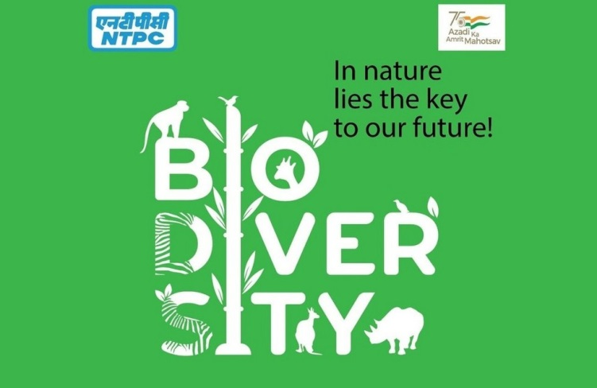
About:
- This Biodiversity Policy is an integral part of NTPC’s Environmental Policy.
- NTPC was the first PSU to issue Biodiversity Policy in 2018. In the same year, NTPC became a member of the India Business & Biodiversity Initiative (IBBI).
- The power major aims to mainstream the concept of biodiversity across NTPC’s value chain.
- The company will further strengthen its current efforts to achieve a ’no net loss’ of biodiversity at all of its currently operating sites.
- NTPC has also signed a five-year agreement with Andhra Pradesh Forest Department for conservation of Olive Ridley Turtles in the coastline of Andhra Pradesh.

