Current Affairs : 31 May 2022

INDUS WATER TALKS BETWEEN INDIA, PAK BEGIN IN NEW DELHI
In News:
- Recently, India and Pakistan began another round of the Permanent Indus Committee meeting.
- The meeting is held annually under the Indus Water Treaty (IWT) 1960.

Background:
- The Indus river basin has six rivers- Indus, Jhelum, Chenab, Ravi, Beas and Sutlej; originating from Tibet and flowing through the Himalayan ranges to enter Pakistan.
- In 1947, the line of partition, aside from delineating geographical boundaries for India and Pakistan, also cut the Indus river system into two.
- Both the sides were dependent on water from the Indus river basin to keep their irrigation infrastructure functional and therefore, equitable distribution was needed.
- Initially, the Inter-dominion Accord of May, 1948 was adopted, where both countries, after meeting for a conference, decided that India would supply water to Pakistan in exchange for an annual payment made by the latter.
  - This agreement however, soon disintegrated as both the countries could not agree upon its common interpretations.
- In 1951, in the backdrop of the water-sharing dispute, both the countries applied to the World Bank for funding of their respective irrigation projects on ​​Indus and its tributaries, which is when the World Bank offered to mediate the conflict.

Indus Water Treaty:
- Finally in September 1960, an agreement was reached between the two countries, and the Indus Waters Treaty (IWT) was signed by former Prime Minister Jawaharlal Nehru and then President of Pakistan, Ayub Khan.

Key Provisions of the Treaty:
- The treaty prescribed how water from the six rivers of the Indus River System would be shared between India and Pakistan.
- It allocated the three western rivers—Indus, Chenab and Jhelum—to Pakistan for unrestricted use, barring certain non-consumptive, agricultural and domestic uses by India and the three Eastern rivers—Ravi, Beas and Sutlej—were allocated to India for unrestricted usage.
- This means that 80% of the share of water or about 135 Million Acre Feet (MAF) went to Pakistan, while leaving the rest 33 MAF or 20% of water for use by India.
- It also required both the countries to establish a Permanent Indus Commission constituted by permanent commissioners on both sides.

Arguments in favour of renegotiation of IWT:
- Poor water development projects have allowed 2-3 MAF of water to easily flow into Pakistan which needs to be urgently utilised.
- Further, out of the total estimated capacity of 11,406 MW electricity that can be harnessed from the three western rivers in Kashmir, only 3034 MW has been tapped so far.

ED ARRESTS SATYENDAR JAIN IN MONEY LAUNDERING CASE
In News: The Delhi Health Minister was recently arrested by the Enforcement Directorate (ED) for allegedly misleading investigations and transferring proceeds of crime, which is a serious offence under the Prevention of Money Laundering Act (PMLA).

The Prevention of Money Laundering Act (PMLA), 2002:
- About:
  - It is an Act of the Parliament of India enacted to prevent money-laundering and to provide for confiscation of property derived from money-laundering.
  - The Act and Rules notified (both came into force with effect from 2005) there under impose obligation on banking companies, financial institutions and intermediaries to verify identity of clients, maintain records and furnish information in prescribed form to Financial Intelligence Unit - India (FIU-IND).

  - Financial Intelligence Unit – India (FIU-IND):
    - It was set by the Government of India in 2004 as the central national agency responsible for receiving, processing, analysing and disseminating information relating to suspect financial transactions.
    - FIU-IND is an independent body reporting directly to the Economic Intelligence Council (EIC) headed by the Finance Minister.

Provisions regarding arrest of sitting MPs/MLAs/Ministers:
- According to the Code of Civil Procedure 1908 (Section 135A), the Union ministers and members of Parliament (MPs) enjoy immunity from arrest in the case of civil matters and cannot be arrested 40 days before, during, or 40 days after a Parliament session.
- However, there is nothing in the rule book that prevents a minister's arrest in a criminal matter.
- The presiding officer of the House (of which the arrested person is a member) must be informed upon his arrest. This information is then notified in the Parliament bulletin if the House is not in session, or informed to the House, if it is in session.
- The only exception to the rule is when a member or minister has to be arrested from the premises of Parliament, the permission of the chair must be sought.
- Under the Indian Constitution (Article 361), immunity from arrest in both civil and criminal matters extend only to the President and governors, who cannot be arrested even in criminal matters while they are in office.
  - Any action, even in criminal matters, may only be initiated after they demit office.

WHAT IS THE WEST NILE VIRUS, HOW DOES IT SPREAD?
In News:
- The Kerala health department is on alert after the death of a 47-year-old from Thrissur due to the West Nile Virus.

West Nile Virus (WNV)
- The West Nile Virus is a mosquito-borne, single-stranded RNA virus.
  - RNA virus is the virus that has single-stranded as well as double-stranded RNA as its genetic material.
  - Noticeable disease caused by RNA virus is (severe acute respiratory syndrome) SARS, influenza, common cold, Hepatitis B and C.
- It is a flavivirus related to the viruses that cause St. Louis encephalitis, Japanese encephalitis, and yellow fever.
  - The Flaviviridae are a family of positive, single-stranded, enveloped RNA viruses. Members of this family belong to a single genus, Flavivirus.
  - They are found in arthropods, (primarily ticks and mosquitoes), and can occasionally infect humans.

Transmission
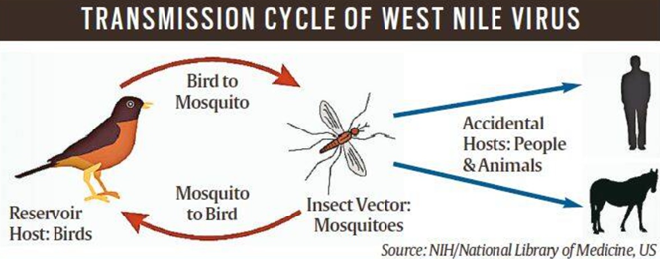
- Culex species of mosquitoes act as the principal vectors for transmission.
- It is transmitted by infected mosquitoes between and among humans and animals, including birds, which are the reservoir host of the virus.
  - Mosquitoes become infected when they feed on infected birds, which circulate the virus in their blood for a few days.
  - The virus eventually gets into the mosquito’s salivary glands.
  - When mosquitoes bite, the virus may be injected into humans and animals, where it can multiply and possibly cause illness.
- It can also spread through blood transfusion, from an infected mother to her child, or through exposure to the virus in laboratories.
- It is not known to spread by contact with infected humans or animals.

Symptoms
- The disease is asymptomatic in 80% of the infected people.
- The rest develop what is called the West Nile fever or severe West Nile disease. For them, the symptoms include:
  - fever, headache, fatigue, body aches, nausea, rash, and swollen glands.
  - It usually turns fatal in persons with co-morbidities and immuno-compromised persons (such as transplant patients).

- Hence, health authorities globally advice for personal protective measures to reduce the risk of mosquito bites such as
  - using mosquito repellents, and
  - for public health departments to ensure larval source reduction especially at breeding and resting sites for the mosquito vectors.

Treatment
- No WNV-specific prophylaxis, treatment or vaccine is available.
- So, only supportive treatments are given to neuroinvasive WNV patients.

BANK PRIVATISATION
The government is in the process of taking ‘advanced action’ to take forward the privatisation of public sector banks, top finance ministry officials asserted.

About:
- In the Union Budget for 2021-22, Union Finance Minister had announced privatisation of two PSBs besides IDBI Bank. However, this year’s Budget Speech had skipped the mention of the progress made for the privatisation of two PSBs.
- Even as the NITI Aayog has suggested names of two PSBs for privatisation, the Centre is yet to make an enabling provision in the law for the divestment of the government’s stake sale below the 51 per cent threshold.
- The government had listed the introduction of Banking Companies (Acquisition and Transfer of Undertakings) Act, 1970, in the Winter Session, but the Bill was not tabled. The Aayog had reportedly suggested privatisation of Central Bank of India and Indian Overseas Bank.
- According to the amendments to the Banking Companies Act moved last year, the government is looking to retain at least 26 per cent stake in PSBs post privatisation.

Procedure
- The approval to privatise the two PSBs is yet to be considered by the Core Group of Secretaries on Divestment (CGD) headed by cabinet secretary.
- Once approved by the CGD, the proposal will be sent to the Alternative Mechanism (AM) that comprises Union Finance Minister Sitharaman and Union Minister of Roads Nitin Gadkari.
- After their nod, the Cabinet will take up the proposal.

FOREIGN MEDICAL GRADUATES
The Supreme Court has upheld the National Medical Commission’s regulations that prescribe certain strictures before foreign medical graduates can practise in India.
About:
- The regulations had in the recent past been a point of debate with relation to Indian students who were forced to return due to the Ukraine crisis.
- The Bench upheld the regulatory validity of the National Medical Commission (Foreign Medical Graduate Licentiate) Regulations, 2021 and the National Medical Commission (Compulsory Rotating Medical Internship) Regulations, 2021.
- The first one requires the foreign medical graduates (FMGs)
  - to undergo a medical course for a minimum of 54 months and an internship for a minimum duration of 12 months in the same foreign medical institution;
  - to register with a professional regulatory body competent to grant licence in the same foreign country and further undergo a supervised 12-month internship in India after applying to the National Medical Commission.
- The second lists rigorous conditions for internship in India for the FMGs.

SUGAR PRODUCTION
After a five-year gap, Maharashtra has overtaken Uttar Pradesh to regain its position as India’s top sugar producer.
About:
- The state’s output for the 2021-22 crushing year (October-September) is expected at 138 lakh tonnes (lt). That is an all-time-high, beating the previous 107.21 lt of 2018-19.
- This record production is attributed to three factors.
- The first is the bountiful rainfall since the 2019 southwest monsoon.
- The second is higher yields from farmers taking extra care of their crop.
- The third factor is a huge jump in “unregistered” cane cultivation. The large “unregistered” area has meant that there is un-harvested cane still in the fields and mills will continue to crush till the first week of June.

SCHOLARSHIP FOR PM CARES CHILDREN
Prime Minister Narendra Modi launched the Scholarship for PM CARES Children Scheme on 30th May, 2022.
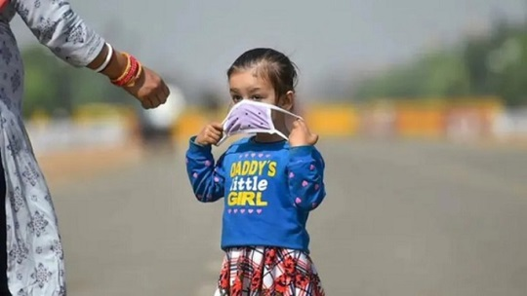
About:
- Prime Minister of India had earlier launched the PM CARES for Children Scheme in 2021.
- Under this Scheme, an initiative was started in Feb 2022 to provide financial assistance to support such children who have lost both the Parents or legal Guardian or Adoptive Parents or Surviving Parent to COVID-19 pandemic.
- In line with the above initiative, the Department of Social Justice & Empowerment, Ministry of Social Justice & Empowerment has decided to provide scholarship assistance to such Children who have lost both the Parents or legal Guardian or Adoptive Parents or Surviving Parent to COVID-19 pandemic to continue their education without any hindrance.
- Accordingly, a new Scheme was formulated for the purpose namely; SCHOLARSHIP FOR PM CARES CHILDREN as a Central Sector Scheme.
- Under the Scheme Scholarship allowance would be ₹20,000/- per child per annum which will comprise monthly allowance of ₹1,000 per month and Annual academic allowance of Rs. 8,000 to cover the entire school fees, cost of the books and uniform, shoes and other educational equipment.
- The Scholarship will be disbursed through DBT to the Children from Class 1std until they pass out the 12 std Class.

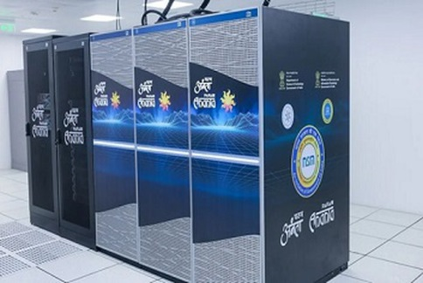
PARAM ANANTA SUPERCOMPUTER
PARAM ANANTA Supercomputer was commissioned on May 30, 2022 at IIT Gandhinagar.
About:
- PARAM ANANTA supercomputing facility is established under Phase 2 of the National Supercomputing Mission (NSM) - a joint initiative of Ministry of Electronics and Information Technology (MeitY) and Department of Science and Technology (DST).
- It is a 838 TeraFlops Supercomputing Facility and is based on Direct Contact Liquid Cooling technology.
- Under NSM, till date 15 supercomputers have been installed across the nation with aggregate compute capacity of 24 petaflops. All these supercomputers have been manufactured in India and operating on indigenously developed software stack developed by Centre for Development in Advanced Computing (C-DAC).

