Current Affairs : 30 May 2022

INDIA – U.S. TRADE TIES
The U.S. surpassed China to become India's top trading partner in 2021-22, reflecting strengthening economic ties between the two countries.
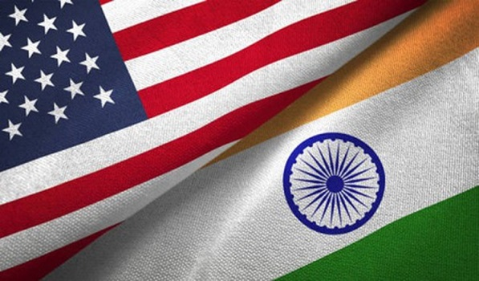
About:
- The bilateral trade between the U.S. and India stood at $119.42 billion in 2021-22 as against $80.51 billion in 2020-21.
- Exports to the U.S. increased to $76.11 billion in 2021-22 from $51.62 billion in the previous fiscal year, while imports rose to $43.31 billion from about $29 billion.
- Experts believe that the trend of increasing bilateral trade with the U.S. will continue in the coming years also as New Delhi and Washington are engaged in strengthening economic ties.
- India has joined a U.S.-led initiative to set up an Indo-Pacific Economic Framework (IPEF) and this move would help boost economic ties further.

India-China trade
- During 2021-22, India’s two-way commerce with China aggregated at $115.42 billion as compared to $86.4 billion in 2020-21.
- Exports to China marginally increased to $21.25 billion last fiscal year from $21.18 billion in 2020-21, while imports jumped to $94.16 billion from about $65.21 billion in 2020-21.
- Trade gap rose to $72.91 billion in 2021-22 from $44 billion in the previous fiscal year.

INTERNATIONAL DAY OF UN PEACEKEEPERS
The International Day of UN Peacekeepers was observed on May 29, 2022. This year, the theme is People Peace Progress: The Power of Partnerships.
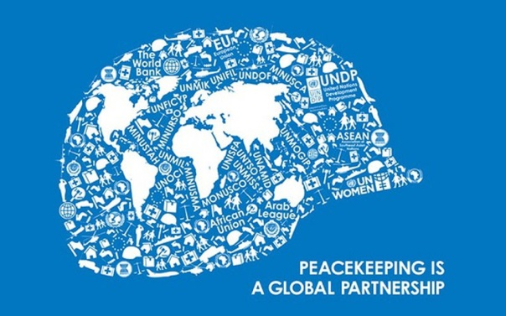
About:
- For the past two decades on this day, UN Peacekeepers, also known as the Blue Helmets, are remembered by the world for their role in promoting security, peace and stability.
- More than one million UN peacekeepers have taken part in 72 such operations since 1948.
- India has played a key role in UN Peacekeeping operations. It sent doctors and nurses to Congo in 1960 and then an all women team to Liberia in 2008.

SECURITY COVERS IN INDIA
VIP security:
- Eligibility:
  - Protection is usually provided to those with high-ranking positions in government or civil society, hence the term "VIP security."
  - Because of their official jobs, certain individuals (the Prime Minister and his immediate family, the Home Minister, the National Security Advisor, etc) are automatically eligible for security coverage.
  - However, the Centre is rarely interested in protecting individuals (except above), state police forces protect a large number of "important people" whose lives are believed to be in danger based on state government assessments.
  - There are no legal restrictions on the government providing security to a criminal whose life is believed to be in danger.
  - In reality, it is the responsibility of the state to protect the lives of inmates and convicts.

- The process of security cover:
  - The Ministry of Home Affairs (MHA) determines the level of security at the national level, while the state government determines the level of security at the state level.
  - The evaluation is based on intelligence agency information, including the Intelligence Bureau (IB) and the Research and Analysis Wing (RAW) at the national level, and the state intelligence department at the state level.
  - The state bears the cost of everyone to whom the government provides security. However, free cover is not a right.
    - Even after conducting a threat assessment, the government may choose to charge a private individual for security.
    - For example, industrialist Mukesh Ambani was asked to pay the CRPF Rs 15 lakh per month for the Z category cover provided in 2013.

- Different degrees of security:
  - Security cover is divided into six categories:
    - X - One gunman;
    - Y - One gunman for mobile security and one (plus four on rotation) for static security;
    - Y plus - Two policemen (plus four on rotation) for mobile security and one (plus four on rotation) for home protection;
    - Z - Six mobile security officers and two (plus eight) resident security officers;
    - Z plus - Ten mobile security officers and two (plus eight) home security officers;
    - SPG (Special Protection Group)
  - Even within these categories, there are different levels of coverage. These include home security, mobile security, office security and inter-state security.
  - While the SPG is reserved for the Prime Minister and his immediate family, other protection categories can be extended to anyone with information about a threat from the Centre or state governments.

- Forces involved:
  - At national level, the National Security Guard (NSG), Central Reserve Police Force (CRPF) and Central Industrial Security Force (CISF) have been designated by the government to provide security cover for VIPs other than the Prime Minister.
    - The Centre has relieved the NSG of the burden of VIP protection. As a result, the security of the Home Minister and the National Security Advisor have been assigned to the CRPF and the CISF, respectively.
  - If a state agrees to provide security, the state police will offer security.

INDIA-BANGLADESH PASSENGER TRAIN SERVICES
The Bangladesh-India passenger train services resumed after two years with the flagging off of the Maitree Express train from Dhaka.
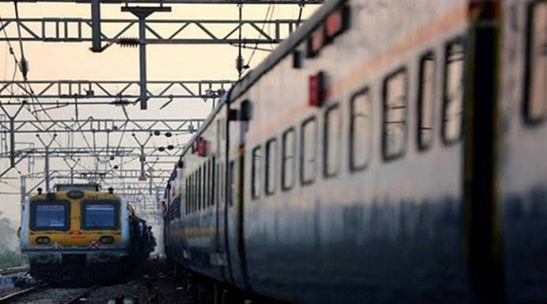
About:
- The Bandhan Express between Kolkata and Khulna was also resumed with the flagging off of the train at Kolkata. It reached Benapole railway station around 9.45 a.m. local time.
- The newly introduced train Mitali Express between New Jalpaiguri and Dhaka will be flagged off jointly by the Railway Ministers of India and Bangladesh on June 1. The train will not have any commercial stoppage between Dhaka and New Jalpaiguri.
- Passenger train services between the two countries had remained suspended for over two year after the outbreak of Covid-19 pandemic in 2020.
- The resumption of the train services was eagerly awaited in Bangladesh as it provides a convenient and cheap mode of connectivity for the people travelling from Bangladesh to India and back.

NATIONAL COUNCIL FOR TEACHER EDUCATION (NCTE)
National Council for Teacher Education (NCTE) under Ministry of Education has launched an online portal to streamline the entire process of recognition of teacher education programs of Higher Education Institutions (HEIs) and Teacher Education Institutions (TEIs).
About:
- This will streamline the entire process right from the time of inviting application for courses till the stage of issue of recognition orders including the inspection of institutions.
- The applications for the recently launched four years Integrated Teacher Education Programmes will be processed on this portal.
- This portal will bring a paradigm shift in the functioning of NCTE. It aims to provide an automated robust framework thereby enhancing accountability, transparency and ease of doing business.

ALL THAT BREATHES
Shaunak Sen’s “All That Breathes” won the 2022 L’Oeil d’Or (Golden Eye) for the best documentary at the 75th Cannes Film Festival, making it two in succession for India.
About:
- “All That Breathes” is about two Delhi brothers Nadeem and Saud who, amid the city’s worsening air and deteriorating social fabric, devote their lives to saving migratory black kites that are at the mercy of mankind’s unthinking ways.
- Sen’s win is India’s second in Cannes in two years. In 2021, Payal Kapadia’s “A Night of Knowing Nothing”, which played in the parallel Semaine de la Critique (Cannes Critics’ Week) took home the L’Oeil d’Or.

CONNECTIVITY PROJECTS IN NORTH-EAST
Union Finance Minister Nirmala Sitharaman said the Centre is implementing various rail, road and air connectivity projects worth ₹1,34,200 crore in Northeast India.
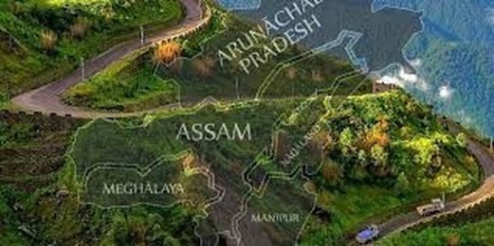
About:
- Addressing the “Natural Allies in Development and Interdependence (NADI)” conclave here, she said the Union government had been pumping in huge money to develop a number of infrastructure projects throughout the region.
- The Centre is carrying out 20 railway projects worth ₹74,000 crore for 2,011 km, which are spread across the northeast.
- The Centre is also developing 4,000 km of roads in the region at a total cost of ₹58,000 crore.
- There are 15 ongoing air connectivity projects in the northeast, costing around ₹2,200 crore.
- India and Bangladesh had 50 riverine systems which could be leveraged for all types of transportation as the cost of travel through water was the least when compared to air, road and rail networks.
- The government is further developing the National Waterways (NW)-1 on the Ganga, NW-2 on the Brahmaputra and NW-16 on the Barak. The entire area between Sadiya and Dhubri in Assam along the Brahmaputra was being developed for better connectivity.
- The Eastern Waterways Connectivity Transport Grid, once completed, will offer seamless connectivity not only between the northeast and the rest of India but also on the subcontinent.

