Current Affairs : 28 May 2022

COMMUNITY FOREST RESOURCE (CFR) RIGHTS
The Chhattisgarh government has become only the second state in the country to recognise Community Forest Resource (CFR) rights of a village inside a national park.
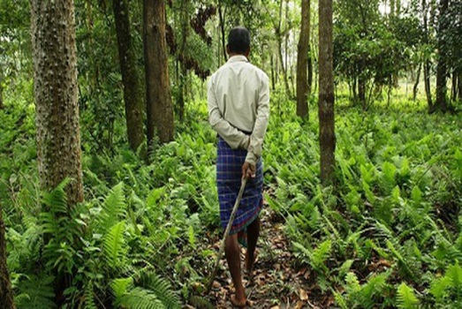
About:
- The CFR rights of tribals living in Gudiyapadar, a hamlet inside the Kanger Ghati National Park in Bastar district, were recognised, giving the community power to formulate rules for forest use.
- Kanger Ghati National Park is the second national park, after Simlipal in Odisha, where CFR rights have been recognised.

What is a community forest resource?
- The community forest resource area is the common forest land that has been traditionally protected and conserved for sustainable use by a particular community.
- The community uses it to access resources available within the traditional and customary boundary of the village; and for seasonal use of landscape in case of pastoralist communities.
- The Community Forest Resource rights under Section 3(1)(i) of the Scheduled Tribes and Other Traditional Forest Dwellers (Recognition of Forest Rights) Act (commonly referred to as the Forest Rights Act or the FRA) provide for recognition of the right to “protect, regenerate or conserve or manage” the community forest resource.

SELA MACAQUE
A new species of old world monkey recorded from Arunachal Pradesh has been named after a strategic mountain pass at 13,700 ft above sea level.

About:
- Sela macaque (Macaca selai), the new-to-science primate was identified and analysed by a team of experts from the Zoological Survey of India (ZSI) and the University of Calcutta.
- Their study has been published in the latest edition of Molecular Phylogenetics and Evolution. Phylogenetics relate to the evolutionary development and diversification of a species or group of organisms.
- The phylogenetic analysis revealed that the Sela macaque was geographically separated from the Arunachal macaque (Macaca munzala) of Tawang district by Sela.
- This mountain pass acted as a barrier by restricting the migration of individuals of these two species for approximately two million years, the study said.
- Sela is situated between Dirang and Tawang towns in western Arunachal Pradesh.
- The study says the Sela macaque has a tail longer than the Tibetan macaque, Assamese macaque, Arunachal macaque and the white-cheeked macaque but shorter than the bonnet macaque and toque macaque.
- Sela macaque belongs to the sinica species-group of Macaca, but it differs from all other members of thisgroup through attributes such as brown collar hair and muzzle, and the absence of chin whiskers, the study says.

GATI SHAKTI TRAIN
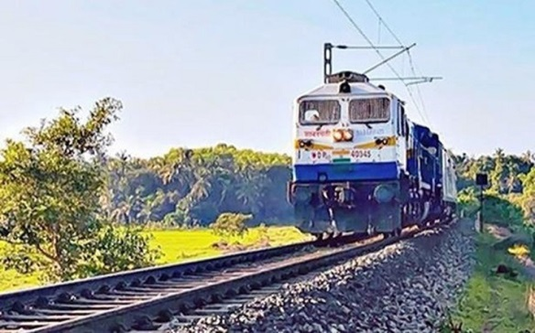
To tap the growing freight sector in the country, the Railways is aiming to introduce the country’s first semi-high speed freight train by December 2022.
About:
- Based on the Vande Bharat platform, the 16-coach ‘Gati Shakti’ train will be able to run at 160 km/hour, and will be manufactured at the Integral Coach Factory (ICF) in Chennai.
- The overall target of 25 such trains had been set. The final number of trains would depend on how the initial trains will be received by market.

Focus on e-commerce
- With these trains, the Railways plans to target the e-commerce and courier parcel segment.
- With the turnover of $50 billion in 2020, India had become the 8th largest market for e-commerce. India’s e-commerce market is expected to reach $111 billion by 2024, $200 billion by 2026 and expected to reach $350 billion by 2030.

INTERNATIONAL BOOKER PRIZE
Tomb of Sand, written by Geetanjali Shree and translated by Daisy Rockwell, has won the 2022 International Booker Prize for Translated Fiction.
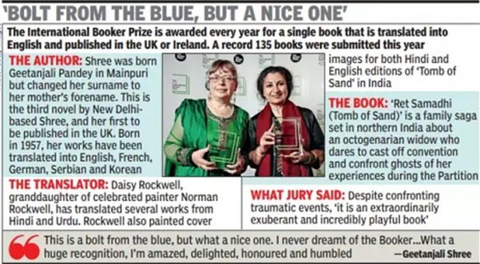
About:
- Tomb of Sand is the first book originally written in any Indian language to win the International Booker Prize, and the first novel translated from Hindi to be recognised by the award.
- Set in northern India, the novel follows the adventures of an 80-year-old woman who unexpectedly gains a new, and highly unconventional, lease of life.
- Shree and Rockwell will split the £50,000 prize money, giving the author and translator equal recognition. This book has also won the English PEN translation award.

Do you know?
- In 2005, the International Booker Prize opened for English translations of foreign language books and from 2016 onwards, it equally recognised the work of both author and translator.
- The award is given every year to a book translated into English and published in Britain or Ireland.
- It’s distinct from the Booker Prize, which has been won by Indian writers like Arundhati Roy and Aravind Adiga in the past.

BHARAT DRONE MAHOTSAV 2022
Prime Minister Narendra Modi inaugurated India's biggest Drone Festival - Bharat Drone Mahotsav 2022. The Prime Minister also gave away 150 drone pilot certificates.
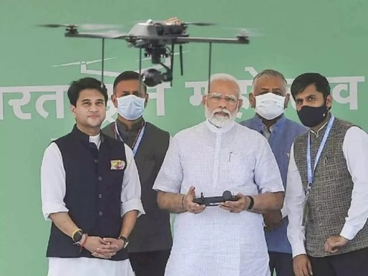
About:
- Several industry leaders, government officials, foreign diplomats, representatives from Public Sector Units, private companies and drone start-ups are participating in the Mahotsav. They will deliberate upon India’s Civil Aviation sector.
- PM Modi highlighted the importance of drone technology in the fields of defence, disaster management, agriculture, tourism, film and entertainment. He said that the use of this technology is bound to increase in the coming days.
- Appreciating the use of drones in PM-SVAMITVA scheme, he said, 65 lakh property cards have been generated with the help of drones.
- Drone industry in India is estimated to achieve 15 thousand crore rupees turnover by the year 2026. He also narrated the use of drones in his official decision making through examples of PRAGATI reviews and Kedarnath projects.

UTTARAKHAND SETS UP EXPERT PANEL FOR UNIFORM CIVIL CODE IMPLEMENTATION

- The Uttarakhand government recently announced the formation of an expert committee to examine ways for implementing a uniform civil code, including a review of laws governing marriage, divorce, maintenance, inheritance, adoption and other personal laws.
- The committee will be led by retired judge Justice Ranjana Prakash Desai, who is also the current chair of the delimitation commission.

The Uniform Civil Code (UCC):
- Background:
  - The idea of a UCC has been present in some form in India since British rule.
  - However, while the British desired the codification of various laws concerning crime, contracts, evidence, etc, they desired to keep Hindu and Muslim personal laws separate as part of their divide-and-rule policy.
  - As a result, while criminal laws in post-independent India are uniform and apply equally to all citizens (regardless of religious beliefs), personal laws implemented through civil laws are influenced by faith.

- About UCC:
  - A Uniform Civil Code provides for one law that applies to all religious communities in personal matters such as marriage, divorce, inheritance, adoption, etc.
  - In India, Article 44 in the Part IV (Directive Principles of State Policy (DPSP)) of the Indian Constitution lays down that the state shall endeavour to secure a Uniform Civil Code for the citizens throughout the territory of India.
  - Article 44 was incorporated into the Constitution as a provision that would be fulfilled when the nation was ready to accept it and the UCC could be socially accepted.

- UCC Vs Personal laws:
  - Personal laws (mentioned in the Concurrent List of the Schedule VII of the Indian Constitution) are laws that apply to a certain group of people based on their religion, caste, faith and belief made after due consideration of customs and religious texts.
    - For example, Hindu personal law is based on ancient texts like Vedas, Smritis and Upanishads and modern concepts of justice, equality, conscience etc. While, Muslim personal law is primarily based on the Quran and Sunnah.
  - The introduction of a UCC is likely to annul all such codified laws and bring in a law that would be common to all citizens.

- Importance of UCC:
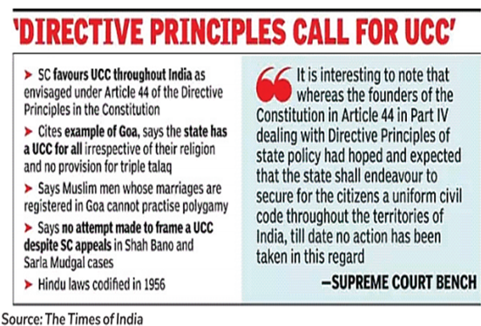
  - It will simplify the complex laws around marriage ceremonies, inheritance, succession, adoptions, etc, as the same civil law will then be applicable to all citizens irrespective of their faith.
  - It seeks to address the discrimination against vulnerable groups (including women and religious minorities) and harmonise diverse cultural groups across the country.
  - It aims to promote nationalistic fervour through unity.

- Challenges in implementing UCC:
  - As defined in Article 37 of the Indian Constitution, the directive principles are not justiciable (not enforceable by any court) but the principles laid down therein are fundamental in governance.
  - Article 44 uses the words “state shall endeavour” (other Articles in the DPSP chapter use words such as “shall be obligation of the state,” etc). This implies that the duty of the state is greater in other directive principles than in Article 44.
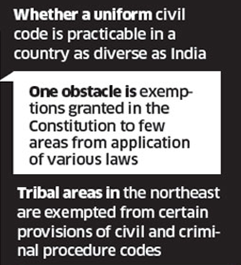
  - It is looked upon as anti-minority and anti-tribal. For example, property succession and marriage laws are governed by traditional and customary procedures in Meghalaya.
    - Similarly, tribal laws differ in other North-eastern states. As a result, UCC may cause some dissatisfaction in the North-eastern region.

- Will Uttarakhand be the first state to bring UCC?
  - Uttarakhand may not be the first state to implement a Uniform Civil Code.
  - Goa has a version of a UCC and it is the only state in India to follow a common law for all its citizens.
    - The coastal state follows the Portuguese Civil Code, 1867, which is survived in accordance with the Goa, Daman and Diu (Administration) Act, 1962.

- Way ahead:
  - According to a Law Commission of India’s 2018 consultation paper, a uniform civil code is "neither necessary nor desirable at this stage" in the country.
  - The goal of a UCC should ideally be reached in a piecemeal manner, like the recent debate on the age of marriage.
  - A just code is far more important than a uniform code.

