Current Affairs : 27 May 2022

MAHATMA GANDHI NATIONAL RURAL EMPLOYMENT GUARANTEE SCHEME (MGNREGS)
The Union government has made capturing of attendance through its app, National Mobile Monitoring System, compulsory at worksites where 20 or more workers are employed under the Mahatma Gandhi National Rural Employment Guarantee Scheme (MGNREGS).
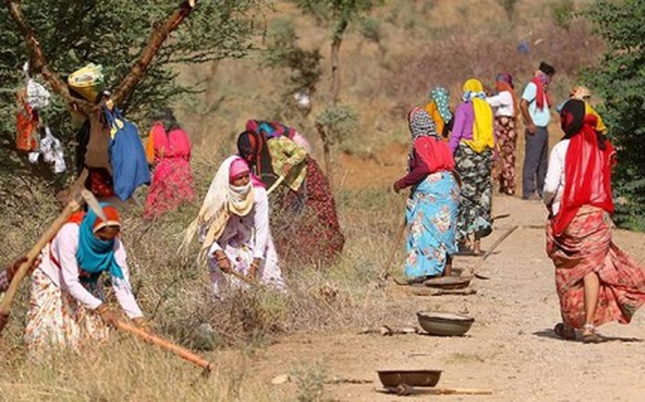
About:
- The Rural Development Ministry had started the exercise on a pilot basis in May 2021.
- Initially, the utilisation of application was to be voluntary, but from May 16, 2022, it has been made mandatory.
- The Ministry’s directive claims that the app, which requires two time-stamped and geotagged photographs of the workers in a day, encourages transparency and increases citizen oversight.
- The decision comes despite many problems, including patchy Internet connectivity in rural areas and little or no technical support. In a majority of cases, the employees’ families are averse to giving phones to women, especially smartphones. Hence, many women have dropped out.

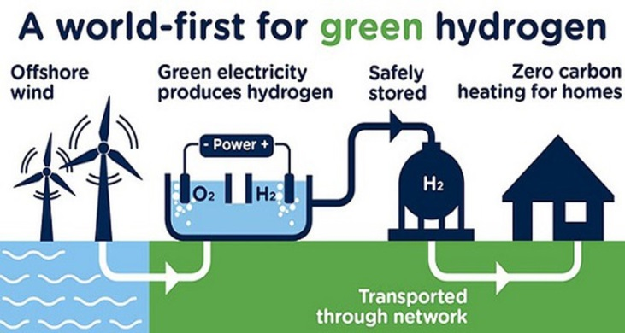
GREEN HYDROGEN
At the World Economic Forum in Davos, Switzerland, Minister of Petroleum and Natural Gas Hardeep Singh Puri said India will emerge as the leader of green hydrogen by taking advantage of the current energy crisis across the globe.

About:
- The ‘green’ depends on how the electricity is generated to obtain the hydrogen, which does not emit greenhouse gas when burned.
- Green hydrogen is produced through electrolysis using renewable sources of energy such as solar, wind or hydel power.

Steps in India
- In Apr Oil India Limited (OIL) commissioned India’s first 99.99% pure green hydrogen plant in eastern Assam’s Jorhat.
- India has just begun to generate green hydrogen with the objective of raising non-fossil energy capacity to 500 gigawatts by 2030.
- The National Hydrogen Mission was launched on August 15, 2021, with a view to cutting down carbon emissions and increasing the use of renewable sources of energy.

Hydrogen can be ‘grey’ and ‘blue’ too.
- Grey hydrogen is generated through fossil fuels such as coal and gas and currently accounts for 95% of the total production in South Asia.
- Blue hydrogen, too, is produced using electricity generated by burning fossil fuels but with technologies to prevent the carbon released in the process from entering the atmosphere.

PROJECT ‘NIGAH’
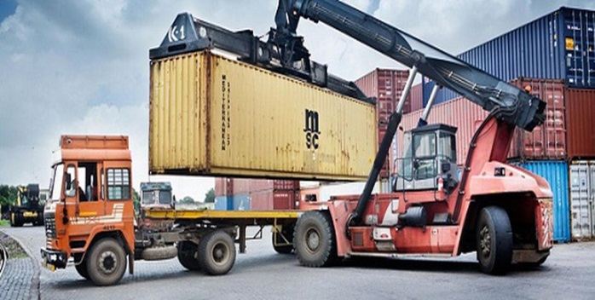
Delhi Customs Zone, a field formation under the Central Board of Indirect Taxes and Customs, inaugurated project ‘NIGAH’ at Inland Container Depots (ICD) Garhi Harsaru, Gurugram.

About:
- Project NIGAH is an initiative to track container by using ICTM (ICD Container Tracking Module) which will help in better visibility of the container movement inside the ICD.
- It will help Customs to expedite long standing containers and monitor timely clearances, thereby enhancing Ease of Doing Business along with ensuring lead preventive checks.

The World Economic Forum (WEF) Annual Meeting 2022

- The World Economic Forum (WEF) Annual Meeting 2022 came to an end on 26 May.
- This was the first global in-person leadership event since the start of the Covid-19 pandemic.

In Focus: World Economic Forum
About
- The World Economic Forum is the international non-governmental organization for Public-Private Cooperation.
  - It was founded in January 1971 by German engineer and economist Klaus Schwab.
- The Forum engages the foremost political, business, cultural and other leaders of society to shape global, regional and industry agendas.
  - It has no independent decision-making power.
- HQ: Cologny-Geneva, Switzerland.

Davos meet:
- Annually, the WEF organizes a meeting at the end of January in Davos, a mountain resort in Graubünden, in the eastern Alps region of Switzerland.
- The Annual Meeting, also known as the Davos Agenda, has the objective of orienting global leaders on the imperatives of the year ahead.

Reports published
- WEF also produces a series of annual reports such as –
  - Global Competitiveness Report,
  - Global Information Technology Report,
  - Global Gender Gap Report,
  - Global Risks Report,
  - Global Travel and Tourism Report,
  - Financial Development Report and
  - Global Enabling Trade Report.

- India sent a record delegation this year
  - From India, three union ministers -- Piyush Goyal, Mansukh Mandaviya and Hardeep Singh Puri -- participated.
  - Beside them, several state leaders including two chief ministers -- Basavaraj S Bommai and Y S Jagan Mohan Reddy – also participated in the meeting.
  - India presented its position on critical global issues like the energy crisis, food security, and health equity at the summit.

- India, leading the transition to green energy
  - The participating Indian leaders highlighted the fact that:
    - 60 million people go to fill up their tanks every day in India; 5 million barrels a day is the Indian consumption.
    - The aim of a 20% ethanol blend has been pushed ahead from 2030 to 2025.
    - Green hydrogen, biofuel discovery, and production from alternate sources is being prioritised.

Why are tribals of Rajasthan and Gujarat demanding a separate state of Bhil Pradesh?

- The demands for a “Bhil Pradesh”, a separate state for tribal people in western India, have of late begun to be raised again.

- Background (Demand for a separate Bhil Pradesh, Reason for this demand, Challenges , Past examples)
- Constitutional Provisions for STs

Background:
- The Bharatiya Tribal Party (BTP), a political party based in Gujarat, envisions Bhil Pradesh as a separate state carved out of 39 districts spread over four states: 16 in Gujarat, 10 in Rajasthan, seven in Madhya Pradesh, and six in Maharashtra.
- Formed in 2017 in Gujarat, the party’s core objective is separate statehood.

Why is the party demanding a separate statehood?
- Earlier, the Dungarpur, Banswara, Udaipur region in Rajasthan and Gujarat, MP, etc. was part of a single entity.
- However, post-independence, many of these tribal majority regions were distributed across the states.
- Economic backwardness of sub-regions within large states has also emerged as an important ground on which demands for smaller states are being made. Linguistic and cultural reasons, which were the primary basis for creating new states in the country, have now become secondary in most of these cases.
- Over the decades, several Union governments brought various “laws, benefits, schemes, and committee reports” on tribals, but went slow on their execution and implementation.
- For example, the Provisions of the Panchayats (Extension to Scheduled Areas) Act, 1996 was enacted in 1996.
  - However, the Rajasthan government adopted the law in 1999, and came out with its Rules in 2011.
  - In many remote areas of the state, majority of the people are still not aware about the provisions of the Act.

Challenges in Creation of New States
- Setting up various institutions, government offices, universities, hospitals, etc. require huge sums of money, therefore, the new state might end up depending on the Union for funds, which may or may not be available.
- Different statehood may lead to the hegemony of the dominant community/ caste/ tribe over their power structures. This can lead to the emergence of intra-regional rivalries among the sub-region
- There is also possibility of increase in the inter-State water, power and boundary disputes.
- Creation of smaller states only transfers power from the old state capital to new state capital without empowering already existing institutions like Gram Panchayat, District Collector, etc. rather diffusion of development in the backward areas of the states.

Past examples
- Jharkhand has failed from the governance and administrative perspective and became state of coal scams and corrupt practices.
- Chhattisgarh has witnessed largest tribal displacement in the recent times
- Uttarakhand continues to be at the end in the Human Development Index. The recent floods showed the inability of the state to deal with rehabilitation of the displaced residents.
- Telangana is heavily relying on the central grants to pay for its newly created administrative and institutional machineries.

