Current Affairs : 26 May 2022

STATE LEVEL STEERING COMMITTEES FOR ENERGY TRANSITION
Union Power Minister R. K. Singh has asked the Chief Ministers of all States and Lieutenant Governors of Union Territories to set up State Level Steering Committees for Energy Transition.
About:
- These Steering Committees will work under the chairmanship of the Chief Secretaries of the States and Union Territories.
- The Principal Secretaries of Power and New and Renewable Energy Departments, Transport, Industries, Housing and Urban Affairs, Agriculture, Rural Development and Public Works Departments will act as members of these Committees.
- The States and Union Territories will work on the annual strategy of energy transition under the mandate of the committee.
- Some states like Andhra Pradesh, Kerala, Madhya Pradesh, and Uttarakhand have already constituted such committees.
- He added that the energy transition is the only means of reducing carbon emissions and fulfilling our commitments made at international forums. He also urged the States to make efforts for zero diesel in agriculture by 2024 by limiting the consumption of diesel in the agriculture sector.

PARAM PORUL SUPERCOMPUTER
PARAM PORUL, a state-of the art Supercomputer at NIT Tiruchirappalli was dedicated to the nation under Phase 2 of the National Supercomputing Mission (NSM).
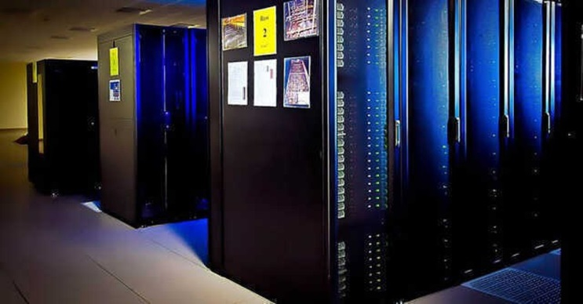
About:
- A MoU was signed between NIT Tiruchirappalli and Centre for Development in Advanced Computing (C-DAC) in 2020 to establish this 838 TeraFlops Supercomputing Facility under NSM.
- NIT, Tiruchirappalli has been carrying out research in the areas of societal interest such as Health, Agriculture, Weather, Financial Services. The facility installed under NSM will strengthen this research.
- PARAM PORUL system is based on Direct Contact Liquid Cooling technology to obtain a high power usage effectiveness and thereby reducing the operational cost.

National Supercomputing Mission (NSM)
- National Supercomputing Mission (NSM) is a joint initiative of Ministry of Electronics and Information Technology (MeitY) and Department of Science and Technology (DST).
- Under NSM, till date 15 supercomputers have been installed across the nation with compute capacity of 24 petaflops. All these supercomputers have been manufactured in India and operating with indigenously developed software stack.

BHIL PRADESH
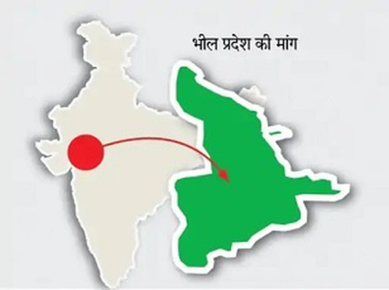
The demands for a “Bhil Pradesh”, a separate state for tribal people in western India, have of late begun to be raised again.

About:
- Bhils or Bheels are an Adivasi ethnic group in West India. Bhils are listed as tribal people of the states of Gujarat, Madhya Pradesh, Chhattisgarh, Maharashtra and Rajasthan
- Bhils are one of the largest tribal group in India. They speak the Bhil languages.

What is ‘Bhil Pradesh’?
- The Bharatiya Tribal Party (BTP), a political party based in Gujarat, was formed in 2017.
- It envisions Bhil Pradesh as a separate state carved out of 39 districts spread over four states: 16 in Gujarat, 10 in Rajasthan, seven in Madhya Pradesh, and six in Maharashtra.

Mangarh massacre
- Bhil social reformer and spiritual leader Govind Guru first raised the demand for a separate state for tribals back in 1913 after the Mangarh massacre.
- The massacre, which took place six years before Jallianwalla Bagh and is sometimes referred to as the “Adivasi Jallianwala”, saw hundreds of Bhil tribals being killed by British forces on November 17, 1913 in the hills of Mangarh on the border of Rajasthan and Gujarat.

ABHILASHA BARAK: FIRST WOMAN COMBAT PILOT OF ARMY
Captain Abhilasha Barak has become the first woman to join the Army Aviation Corps as combat aviator after completion of a six-month combat Army aviation course.
About:
- She has been awarded the coveted wings along with 36 Army pilots during a valedictory ceremony at the Combat Army Aviation Training School, Nashik.
- Barak hails from Haryana and was commissioned into the Army Air Defence Corps in September 2018.
- The Army Aviation Corps, the youngest Corps of the Army, was formed on November 1, 1986 and over the years, has expanded with addition of new units and equipment such as Cheetah and the advanced light helicopter Dhruv, weaponised Rudra and the light combat helicopter.
- In August 2021, Army Aviation got control of the unmanned aerial vehicles (UAV), which were earlier with the Artillery, bringing all aviation assets under one roof.

NATIONAL ACHIEVEMENT SURVEY (NAS) 2021 REPORT
The Department of School Education and Literacy, Ministry of Education released the National Achievement Survey (NAS) 2021 report. The last NAS was held in 2017.
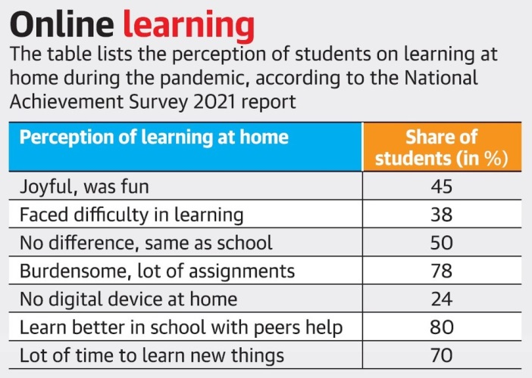
About:
- It assesses the health of school education system in the country by conducting comprehensive evaluation survey of children’s learning competencies at classes III, V, VIII and X with a cycle period of three years.
- The report also evaluated competencies of students in subjects such as mathematics, languages, and environmental studies (EVS) for Classes 3 and 5; language, mathematics, science and social science for Class 8; and language, mathematics, science, social science and English for Class 10.

Findings
- Nearly 80% students found learning at home during the pandemic “burdensome” and felt that they learnt better in school with help from peers.
- As many as 24% students said they had no digital device at home. Though 45% students found the experience “joyful”, 38% also said that they had difficulties in learning.
- Out of a score of 500, students across various classes performed better in languages, but lagged behind in subjects like mathematics and science.
- across various subjects and classes, SC, ST and OBC students perform worse than general category students.

Yasin Malik gets life term for terror funding
- A special court sentenced Kashmiri separatist leader Yasin Malik to life imprisonment in a terror funding case.

The Unlawful Activities Prevention Act (UAPA), 1967
About
- Enacted in 1967, UAPA is the primary counter-terror law in India.
- It was enacted to outlaw and penalise unlawful and terrorist activities, which pose a threat to the integrity and sovereignty of India.
- However, the terror law has come under sharp scrutiny recently with various courts finding application of the UAPA arbitrary.

Key provisions
- Wide ranging powers to Central Govt
  - It provides wide-ranging powers to the Central Government to designate organisations as terrorist organisations and
  - It also prescribes the penalties for taking part in the activities of such organisations.

- Applicability
  - It is also applicable if the offencesare committed outside India.
  - Both Indian and foreign nationals can be charged.

- Timeline
  - A charge sheet can be filed in maximum 180 days after the arrests.
  - The investigation has to be completed within 90 days.
  - If investigation is not completed with the stipulated time, the accused is eligible for default bail.

How did UAPA become a terror law?
- The first terror law in India was enacted in the form of the Terrorist and Disruptive Activities Prevention Act, 1987 (TADA).
  - TADA came under sharp criticism by human rights organisations and political parties for its application in the aftermath of 1993 Bombay blasts.
  - TADA was allowed to lapse in 1995.
- In 2002, the Vajpayee government brought the Prevention of Terrorism Act (POTA) to deal with terrorism.
  - POTA was repealed by the Manmohan Singh government in 2004
- After POTA was repealed, the UAPA was expanded to include what would have been terrorist acts in earlier laws.

- Terror funding
  - The court observed that funds mobilised by the JKLF chairman were used to create unrest in the form of paid terror activities of stone-pelting and arson on a mass scale.
  - The court noted it is high time that terror funding is recognised as one of the gravest offences and be punished more severely.

- Concurrent life term awarded
  - While noting that financing is the backbone of any operation, including terrorist activities, the court chose the maximum sentence of life imprisonment under Section 17 of the UAPA.
  - The court handed him a concurrent life term under Section 121 (waging war against the state) of the IPC.

