Current Affairs : 25 May 2022

What China aims to achieve by building a second, bigger bridge on Pangong Tso

- The Ministry of External Affairs has confirmed that China is building a second bridge on the Pangong Tso
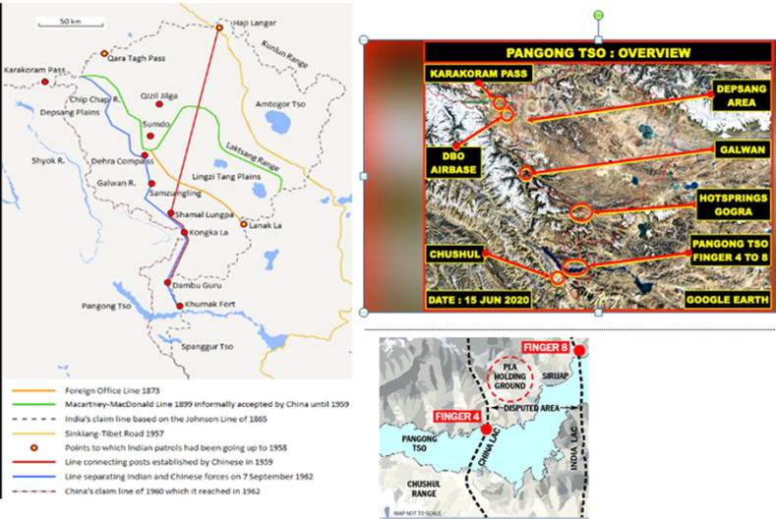
- Although it is being built in territory that is under China’s control since 1958, the exact point is just west of India’s claim line, which India considers it its own territory and the area as illegally occupied by China.
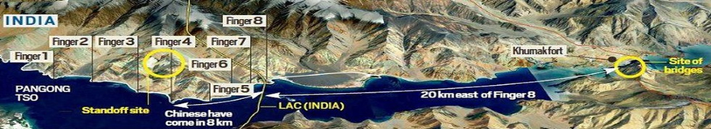

Background of China’s Construction
- Military Standoff: Indian troops outmaneuvered the People’s Liberation Army to occupy the “heights of Kailash Range” in the Chushul sub-sector on the south bank of Pangong Tso in 2020.
- Control strategic location: The positions allowed India to dominate the strategically significant Spanggur Gap, which could be used to launch an offensive as China had done in 1962. Also, India got a direct view of China’s Moldo Garrison. This was a cause of immense concern for the Chinese.
- Readjustment: After this operation, the Indian Army also readjusted on the lake’s north bank to position themselves above Chinese positions. The north bank was one of the first friction points to have come up in May 2020.
- Withdrawal: The two sides finally agreed to pull back troops from these areas in February 2021, an year after spending a harsh winter on those heights.
- Weaponry: Both sides have over 50,000 troops each in the region, in the depth areas, along with additional air defence assets, artillery, tanks and other weapons.

- Pangong Tso is a 135-km long landlocked lake that is partly in the Ladakh region and partly in Tibet. India has around 45 km of Pangong Tso under its control, while China has more than two-thirds.

Significance for China
- Opening multiple fronts: The motive behind China’s construction of bridges is to open multiple routes to counter possible Indian operations.
- Outcome of stand-off: The constructions are a direct outcome of the ongoing standoff that began in May 2020, which catalysed the construction of infrastructure by both sides across the entire 3,488-km long LAC.
- Strategic location: The bridges are at one of the narrowest points on the lake, close to the LAC. And facilitate faster movement of mechanised forces, heavy weapons etc
- Reduce distance: The bridge was aimed at cutting down a 180-km loop from Khurnak to the southern banks through Rudok. This would mean that the route from Khurnak to Rudok would come down to 40-50 km.
- Reduce time for troop mobilization: These bridges will allow Chinese troops to slash travel time from around 12 hours at the moment to around four hours.
- Vehicular movement: This second bridge will allow swift movement of armoured vehicles between the north and the south banks of Pangong Tso.
- Counter future threats: China's People's Liberation Army aims to counter any possible operations by the Indian forces on the southern banks of the Pangong Tso in the future.

60% e-waste recycling likely by 2023
- Recently, the Union Ministry of Environment, Forest and Climate Change made public the draft notification for electronic waste management rules.
- The rules, which have been put up for public feedback, are expected to come into effect by August, 2022.

News Summary:
- A wide range of electronic goods, including laptops, landline and mobile phones, cameras, recorders, music systems, microwaves, refrigerators, electronic office equipment, computers, television sets , electronic entertainment devices and medical equipment have been specified in the notification.
- Timeline
  - As per the draft notification, consumer goods companies and makers of electronics goods have to ensure at least 60% of their electronic waste is collected and recycled by 2023 with targets to increase them to 70% and 80% in 2024 and 2025 respectively.
- Extended Producer Responsibility (EPR) Certificates:
  - Along with specifying targets, the rules also lay out a system for companies securing EPR certificates.
  - These certificates certify the quantity of e-waste collected and recycled in a particular year by a company and an organisation. It may sell surplus quantities to another company to help it meet its obligations.
- Penalty for non-compliance:
  - Companies that don’t meet their annual targets will have to pay a fine or an ‘environmental compensation’ but the draft doesn’t specify the quantum of these fines.
  - In fact, companies that fall short can meet a year’s target, even after three years.
  - Those that meet their targets with a year’s delay will be refunded 85% of their fine, after two years, 60% and 30% after the second and third year respectively.

Electronic-waste in India:
- According to a 2020 report by the Central Pollution Control Board, India generated 1,014,961 tonnes of e-waste in FY 2019-2020 – up 32% from FY 2018-2019.
- Of this, the report found that only 6% and 10% were actually collected in the country in 2018 and 2019, respectively.
- It also said that the informal sector controls more than 90% of e-waste collection and handling processes in the country.
  - The latest draft guidelines for e-waste management proposes to have more of this waste to be handled by the formal sector.

Amendment to EWM Rules, 2016:
- In 2018, the EWM Rules were further amended.
- The new E-Waste (Management) Amendment Rules, 2018 has the provision of introduction of Producer Responsibility Organisation (PRO)
  - PROs are now required to register with CPCB under the new Rules.
- PROs will also have to prove that all collection is legitimate and share proofs for such collection.
- Earlier, PROs were not able to procure waste from private and government institutions.
- The Rules address this lack of acknowledgement of legitimate PROs by asking them to register with CPCB.

Challenges associated with E-waste Management:
- Volume of e-waste generated:
  - India stands fifth in the amount of e-waste generated in the world.
- Involvement of child labour:
  - In India, about 5 lakh child laborers in the age group of 10-14 are observed to be engaged in various E-waste activities and that too without adequate protection and safeguards in various yards and recycling workshops.
  - So, there is a urgent need to bring out effective legislation to prevent entry of child labour into E-waste market- its collection, segregation and distribution.
- Ineffective legislation:
  - There is absence of any public information on most SPCBs/PCC websites.
  - 15 of the 35 PCBs/PCC do not have any information related to E-waste on their websites, their key public interface point.
  - Even the basic E-waste Rules and guidelines have not been uploaded.
- Poor awareness & sensitization:
  - Limited reach out and awareness regarding disposal, after determining end of useful life.
  - Also Only 2% of individuals think of the impact on environment while disposing off their old electrical and electronic equipment.
- E-waste imports:
  - Cross-border flow of waste equipment into India- 80% of E-waste in developed countries meant for recycling is sent to developing countries such as India, China, Ghana and Nigeria.

Quad is a ‘force for good’: Modi
- PM Modi participated in the second in-person Quad Leaders’ Summit in
News Summary
- The second in-person Quad summit took place at Tokyo, Japan. The summit saw the participation of leaders of Australia, India, Japan and the United States.
- Just over one year ago, the Quad Leaders met for the first time. However, the Tokyo was their fourth meeting (second in person meeting).

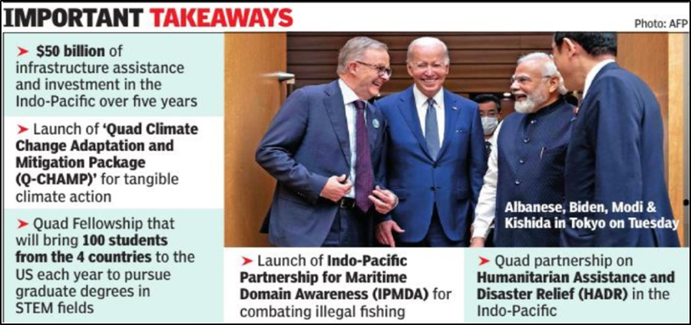
Key Highlights

- Peace and Stability
  - Quad leaders discussed the conflict in Ukraine and the ongoing tragic humanitarian crisis, and assessed its implications for the Indo-Pacific.
  - They expressed their commitment towards cooperation with partners in the region who share the vision of a free and open Indo-Pacific.

- On China
  - Without naming China, the joint statement called out Beijing and strongly opposed any coercive, provocative or unilateral actions that seek to change the status quo and increase tensions.
  - It also emphasised the need for the maintenance of freedom of navigation and overflight, to meet challenges to the maritime rules-based order, including in the East and South China Seas.

- COVID-19 and Global Health Security
  - To date, the Quad partners have collectively pledged approximately USD $ 5.2 billion to the COVAX Advance Market Commitment (AMC).
  - It has delivered over 670 million doses, including at least 265 million doses to Indo-Pacific.
  - The participating leaders expressed their commitment to continue to share quality-assured COVID-19 vaccines where and when they are needed.

- Climate
  - The summit launched the "Quad Climate Change Adaptation and Mitigation Package (Q-CHAMP)” with mitigation and adaptation as its two themes.
  - Q-CHAMP includes ongoing activities under the Quad Climate Working Group on:
    - green shipping and ports aiming for a shared green corridor framework building on each Quad country’s input;
    - clean energy cooperation in clean hydrogen and methane emissions from the natural gas sector;
    - strengthening clean energy supply chains, welcoming the contribution of the Sydney Energy Forum;
    - climate information services for developing an engagement strategy with Pacific Island countries; and
    - disaster risk reduction, including disaster and climate resilient infrastructure

- Critical & Emerging Technologies
  - In the area of 5G and beyond 5G, the participating leaders decided to advance interoperability and security through the signature of a new Memorandum of Cooperation on 5G Supplier Diversification.
  - The Common Statement of Principles on Critical Technology Supply Chains was launched on the occasion of this Summit.
    - This advances the cooperation among Quad countries on semiconductors and other critical technologies.

- Quad Fellowship
  - The Quad Fellowship was officially launched.
  - The Fellowship will bring 100 students from Quad countries to the United States each year to pursue graduate degrees in STEM fields.

MONKEYPOX
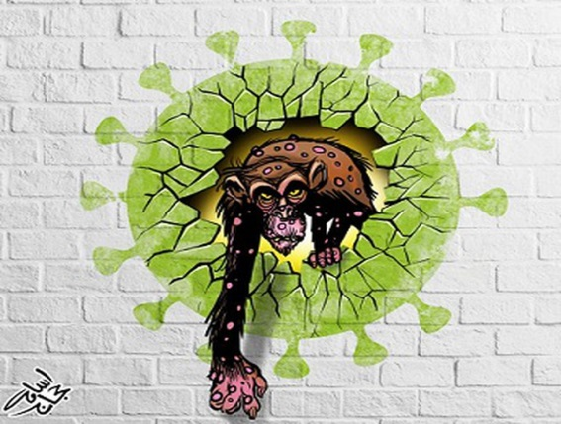
A new study on monkeypox published in The Lancet suggests that some antiviral medications might have the potential to shorten symptoms and reduce the amount of time a patient is contagious.

About:
- The study documents patients’ response to two antiviral medications – brincidofovir and tecovirimat. These were developed to treat smallpox, and have previously demonstrated some efficacy against monkeypox in animals.
- Monkeypox, a rare disease, is caused by a virus that is a close relative of the smallpox virus. There are currently no licensed treatments.

View of WHO
- The World Health Organization (WHO) has said that Monkeypox can be contained in countries outside of Africa where the virus is not usually detected.
- According to media reports, more than 100 cases of the virus, which causes a rash and a fever have been confirmed in Europe, Americas, and Australia.
- The virus is most common in remote parts of Central and West Africa.

ABHA MOBILE APP
National Health Authority (NHA) has launched revamped Ayushman Bharat Health Account, ABHA mobile application to manage health records under Ayushman Bharat Digital Mission.
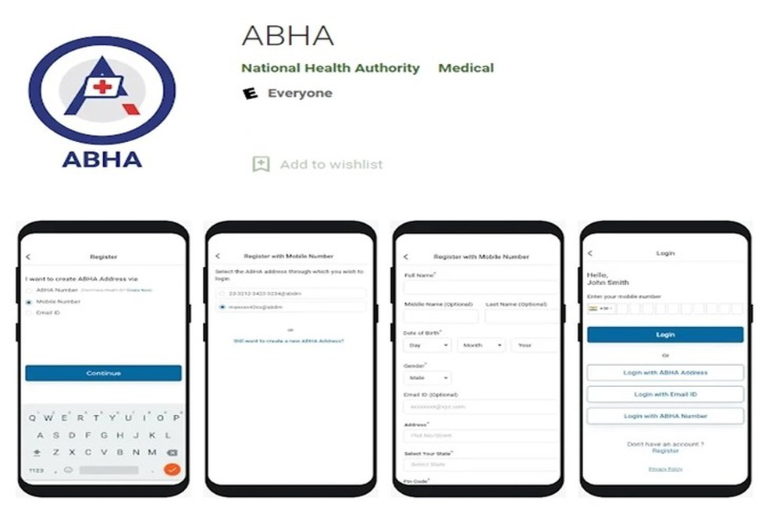
- The ABHA app was previously known as NDHM Health Records app.
- The ABHA mobile application enables an individual to create an ABHA address, an easy-to-remember username that can be linked with the 14-digit randomly generated ABHA number.
- The mobile application also enables users to link their health records created at Ayushman Bharat Digital Mission compliant health facility and view them on their smartphones.
- The application also allows self-uploading of physical health records, along with sharing of digital health records such as diagnostic reports, prescriptions, CoWIN vaccination certificates after the consent of an individual.

PRITHVIRAJ CHAUHAN
There is controversy around a new Akshay Kumar film called ‘Prithviraj’, with both the Gujjar and Rajput communities of Rajasthan laying claim over the 12th century king.
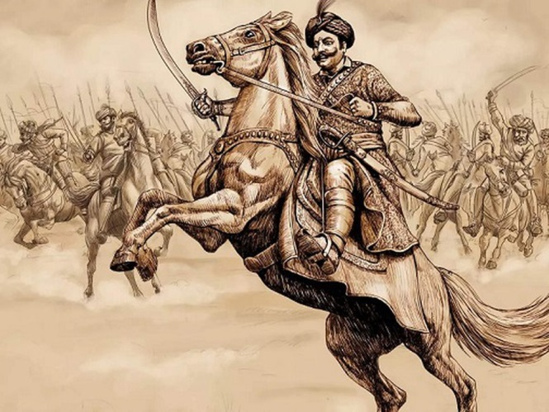
- Prithviraj belonged to the Chauhan or Chahamana dynasty of Ajmer which emerged after the decline of the Pratihara empire in the 11th century AD.
- He ascended the throne in 1177 or 1178, and very quickly expanded his kingdom, defeating many of the smaller Rajput states.
- However, he struggled against the Chalukyas of Gujarat, and was forced to look towards the Ganga valley instead.
- While Prithviraj’s army was able to decisively defeat the invading Ghurids in the First Battle of Tarain (present-day Haryana) in 1191, he was defeated in the Second Battle of Tarain in the following year.
- The battle marked a watershed moment in the history of medieval India, paving the way for the establishment of the Delhi Sultanate and the beginning of Muslim rule.
- Prithviraj was depicted in ‘Prithviraj Raso’, a poem in Brajbhasha attributed to Chand Bardai, which is thought to have been composed in the 16th century.

