Current Affairs : 24 May 2022

ASHA: A SUCCESSFUL PUBLIC HEALTH EXPERIMENT ROOTED IN THE VILLAGE COMMUNITY

- The World Health Organisation (WHO) has recognized India’s 4 lakh ASHA (Accredited Social Health Activist) workers as ‘Global Health Leaders’ for their efforts in connecting the community to the government’s health programmes and their work during Covid-19 pandemic.
- WHO acknowledged that ASHAs facilitate linking households to health facilities, and play pivotal roles in house-to-house surveys, vaccination, public health and Reproductive and Child Health measures.
- ASHA received the Global Health Leaders Award-2022 in the backdrop of the on-going 75th World Health Assembly.

About ASHA
- ASHA is a trained female community health activist recognized as a key component of the National Rural Health Mission (NRHM).
- Selection criteria for ASHAs: In rural areas, ASHA must primarily be a woman resident of the village married/ widowed/ divorced, preferably in the age group of 25 to 45 years and literate preferably qualified up to 10th standard (formal education up to Class 8).
  - In urban areas, ASHA must be a woman resident of the “slum/vulnerable clusters” and belong to that particular vulnerable group which have been identified by City/District Health Society for selection of ASHA and must have good communication and leadership skills

- Number across country: There are around 10.4 lakh ASHA workers across the country, with the largest workforces in states with high populations – Uttar Pradesh (1.63 lakh), Bihar and Madhya Pradesh. Goa is the only state with no such workers, as per the latest National Health Mission data available from September 2019.

- Availability of ASHA: The aim is to have one ASHA for every 1,000 persons or per habitation in hilly, tribal or other sparsely populated areas.

Genesis & evolution of ASHA
- The ASHA programme was based on Chhattisgarh’s successful Mitanin programme, in which a Community Worker looks after 50 households.

  - The National Rural Health Mission (NRHM) was launched in 2005.
  - In 2013, National Urban Health Mission (NUHM) was launched. Both NRHM and NUHM were then subsumed under National Health Mission (NHM).

CENTRE EASES PENSION RULES FOR KIN OF MISSING GOVERNMENT EMPLOYEES

- Recently, the government has eased pension rules for the families of missing Central government employees covered by the National Pension Scheme (NPS).
  - With amended rules, the family members would immediately get the pension benefits after a government employee has gone missing and not wait to get declared dead in government records.
  - In case s/he reappears and resumes service, the amount paid as family pension during the intervening time of his/her missing period can be accordingly deducted from his salary.
- The changes will also apply to those covered under the Old Pension rules.
- Previously, if an employee went missing, his next of kin would not receive the family pension, and it would not be paid until the missing employee was declared dead in accordance with the law, or until seven years had passed.

National Pension Scheme (NPS):
  - NPS is a voluntary and long-term investment plan for retirement under the purview of the Pension Fund Regulatory and Development Authority (PFRDA), Ministry of Finance, Government of India.
  - It was launched in January 2004 for government employees when the Government of India decided to stop defined benefit pensions for all its employees who joined after 1 April 2004.
  - It was opened up for all citizens of India between the age of 18 and 65 in 2009 and for Overseas Citizen of India (OCI) card holders and Persons of Indian Origin (PIO) in 2019.
  - In 2021, PFRDA increased the entry age for the NPS from 65 years to 70 years.

INDIA TO BE THE LEADER OF GREEN HYDROGEN: PURI
- India will emerge as the leader of green hydrogen, Minister of Petroleum and Natural Gas Hardeep Singh Puri recently made the remarks while attending the World Economic Forum at Davos, Switzerland.

About Hydrogen:
- Hydrogen is the lightest chemical element.
- It is colourless, odourless, tasteless, non-toxic, and highly combustible.
- It is the 3rd most abundant element in the human body.
  - The two most abundant elements in human body are Oxygen and Carbon.
- Hydrogen is the most abundant chemical substance in the universe, constituting roughly 75% of all normal matter.
- Hydrogen can be produced from a range of resources including fossil fuels, nuclear energy, biomass and renewable energy sources.

Types of Hydrogen:
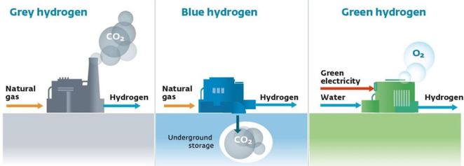
- Depending on production methods, hydrogen can be Grey, Blue or Green.

- Grey Hydrogen:
  - Grey hydrogen is created from natural gas, or methane, using Steam Methane Reformation (SMR) but without capturing the greenhouse gases made in the process.
- Blue Hydrogen:
  - Hydrogen is labelled blue whenever the carbon generated from steam reforming is captured and stored underground through industrial carbon capture and storage (CSS).
- Green Hydrogen:
  - Green hydrogen is produced by using clean energy from surplus renewable energy sources, such as solar or wind power, to split water into two hydrogen atoms and one oxygen atom through a process called electrolysis.

U.S. TO DEFEND TAIWAN AGAINST CHINA: BIDEN
- US President Joe Biden indicated that he would use military force to defend Taiwan if it were ever attacked by China.
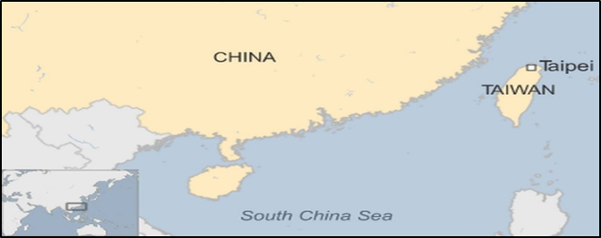
  - This was indicated by Biden at a news conference with Prime Minister Fumio Kishida of Japan during his visit to Tokyo.
- Taiwan is located north of the Philippines and the South China Sea.
- It is about 180 km off the south-eastern coast of China.
- It is separated from the mainland by the Taiwan Strait.

Disagreement and confusion about Taiwan
- China regards Taiwan as a breakaway province which it has vowed to retake, by force if necessary.
  - China has repeatedly insisted that Taiwan should be called “Chinese Taipei”, in efforts to prevent international recognition of Taiwan as a country.
- But Taiwan's leaders argue that it is a sovereign state. Taiwan continues to participate in international events and dialogues separately.
  - It has its own constitution, democratically-elected leaders, and about 300,000 active troops in its armed forces.

OIL AND NATURAL GAS CORPORATION LTD. (ONGC)
Oil and Natural Gas Corporation Ltd. (ONGC) has become the first Exploration and Production (E&P) company in India to trade domestic gas on Indian Gas Exchange.
- The first online trade was made on 23 May 2022 by ONGC Director (Onshore) In-charge Marketing on India’s first automated national level Gas Exchange, IGX.
- The gas traded is from ONGC Krishna Godavari 98/2 block.

Do you know?
- The Oil and Natural Gas Corporation (ONGC) is an Indian oil and gas explorer and producer.
- It is under the ownership of Ministry of Petroleum and Natural Gas, Government of India.
- Its headquarters is situated in New Delhi.
- ONGC was founded on 14 August 1956 by the government of India.
- It was conferred with 'Maharatna' status by the Government of India in November 2010.
- On Jan 30th 2018, ONGC acquired the entire 51.11% stake of Hindustan Petroleum Corporation Limited (HPCL).

WORLD MAY HAVE LOST 11.2 CRORE JOBS: ILO
- The world of work is being buffeted by multiple crises, says the ninth edition of the International Labour Organisation (ILO) Monitor.

International Labour Organisation (ILO)

- The ILO, headquartered at Geneva, Switzerland, is a specialized agency of the United Nations (UN).
  - It was established in 1919, as part of the Treaty of Versailles.
- It is responsible for setting labour standards, develop policies and devise programmes promoting decent work for all women and men.
- It is the only tripartite N. agency which brings together governments, employers and workers of 187 member States.
- Parent organization: Economic and Social Council of the United Nations

India and ILO
- Recently, in June 2021, India completed its term as chair of the Governing Body of the ILO.
  - Governing Body is the apex executive body of the ILO which decides policies, programmes, budget and elects the Director-General.
  - India had assumed the chairmanship after a gap of 35 years. It held the position for the period October 2020- June 2021.

Key Highlights of the report
- Number of hours worked globally dropped
  - The report finds that after significant gains during the last quarter of 2021, the number of hours worked globally dropped in the first quarter of 2022.
    - It dropped to 3.8 per cent below the pre-crisis benchmark (fourth quarter of 2019).
    - This is equivalent to a deficit of 112 million full-time jobs. In other words, about 11.2 crore jobs might have lost between this period.

