Current Affairs : 23 May 2022

eVTOLs
India will see the deployment of electric vertical take-off and landing (eVTOL) aircraft to ensure urban air mobility in the days to come, said Jyotiraditya Scindia, Union Minister for Civil Aviation.
An electric vertical take-off and landing (eVTOL) aircraft is a variety of VTOL (vertical take-off and landing) aircraft that uses electric power to hover, take off, and land vertically.

- This technology came due to major advances in electric propulsion (motors, batteries, fuel cells, electronic controllers) and the growing need for new vehicles for urban air mobility (air taxi).
- Examples are being developed by aircraft companies such as Boeing, Airbus, Embraer, Honda, Toyota, Hyundai and NASA.

SC PANEL REPORT ON ACTION AGAINST ‘ENCOUNTER’ COPS MAY PUT TELANGANA GOVT. IN A BIND

- The Justice V S Sirpurkar Commission's recommendation that murder charges be filed against the 10 police officers involved in the alleged encounter killing has put the Telangana government in a difficult situation.
- The Supreme Court of India (SC) set up the Commission to investigate the deaths of the four accused in the rape and murder of a veterinarian (in 2019) on the outskirts of Hyderabad.

Extra judicial killings:
  - Extra judicial killings as the name suggests are the killings which are not under the purview of law.
  - When an alleged accused has been prosecuted or killed before receiving the orders of such prosecution from the court of law, it is known as extra judicial killings or custodial violence.
  - It violates the fundamental rights of a citizen under Article 14 (Right to Equality), 21 (Right to Life), 22 (Protection against arrest and detention in certain cases) of the Indian Constitution.

- Reasons for the extra judicial killings:
  - Work pressure: As soon as a crime is committed, police are under pressure from various sources to improve their performance and conduct an investigation as soon as possible.
  - Punitive violence: Police use a variety of methods to torture criminals in order to deter those who are about to commit a crime.
  - Positive reinforcement: Using shortcuts to get quick results.
  - Lack of proper training: Lack of training for policemen causes an increase in third-degree techniques.
  - Other Reasons

- Laws dealing with extra judicial killings:
  - The police force has the right to injure or kill the criminal, for the sole and only purpose of self-defense or where it is imminently necessary for the maintenance of peace and order.
  - Under Indian Penal Code (IPC Section-96), every human being has the right to private defense which is a natural and an inherent right.
  - The Criminal Procedure Code (CrPC Section 46) allows police officials to use ‘all means necessary' to arrest a detainee. The use of excessive force than actually required may cause death.
  - There is an Armed Forces (Special Powers) Act, which gives the Indian Defense Force broad powers to use lethal force in a variety of situations.
    - It fails to provide safeguards in the event of excessive use of such powers, resulting in varied accounts of violations committed in areas where AFSPA is applied.

- What if the police personnel are found guilty?
  - The police staff will be charged under Section-299 of the IPC for the punishable crime.
      - If concluded by the materials or evidence, disciplinary action against such officer must be promptly initiated and he be placed under suspension.
    - Compensation to be granted to the dependents of the victim who suffered death in a police encounter.

News Summary:
- The Commission’s report and the case has been transferred to the Telangana High Court.
- If the HC upholds the recommendation, the government will be forced to decide whether to take action against them because it may go against public opinion.
- The Telangana government, which was under public pressure to bring the alleged rapists to justice, did not condemn the alleged encounter killing of the four accused, two of whom are now proven to be minors.
- The government is also accused of failing to press the Special Investigation Team, which was formed to investigate the alleged encounter.
- According to sources, if the government is forced to act against the cops, it may open the door to litigation in other encounter cases as well.

TOUR OF DUTY
- The Army is finalising the finer details of the Tour of Duty plan, which is planned to replace the existing structure of joining the force.
  - The final structure of the programme could be ready as early as by May end.
  - Once the Army approves the plan, it will be up to the government to announce and implement it.
  - Defence officials are hopeful that the government will give a go ahead soon as no new recruitment has taken place for two years.

About
- Under this scheme, the Defence Ministry is starting a new recruitment process for the armed forces that will be for a short span of three-years.
- It will allow civilians of the country to join the Indian Army for three years and serve the country as an army soldier.
- The Indian Army will be the first of the three-armed forces to recruit some soldiers for a fixed period of three years.

- Selection
  - The selected candidates will get a chance to serve the nation as officers and/or other ranks in the Army.
  - Initially, the number of vacancies in the Indian Army would be around 100 which could be expanded later.
  - The draft of the scheme states that all soldiers in the Army would eventually be recruited under the model.

- Time period
  - While initially planned as a three-year Tour of Duty, the final structure could make it for four to five years.
    - One-year training and two-year service after that was too short a time period.
    - At the moment jawans retire after 17 years of service.
  - As per the reports, around 25% of them would serve in the Army for three years and 25% troops would serve for five years.
  - The remaining 50% would continue to serve in the Army for the full term till they reach their retirement age.

- Perks & Benefits
  - Proposal states that 50% of soldiers released at the end of three and five years will be included in National Pension Scheme.
  - Such soldiers will be given certain medical benefits, applicable to Armed Forces veterans, for a fixed period.
  - A Tour of Duty Army officer will be earning somewhere around Rs 80,000 to Rs 90,000 per month salary.

- Current structure overhauled
  - Under the current structure, soldiers are inducted into the regiments based on their caste and the region where they come from.
    - This structure is an inheritance of the days of the British empire.
  - However, the new structure will make it pan-India and independent of the caste.

Significance
- Foundation stone for New India
  - The scheme will ensure that a trained, disciplined, confident, and committed workforce is available for government jobs and to the corporate world.
- Reduction in Defence Expenditure
  - The scheme is also expected to reduce the Army’s pension burden, as the country has a large population of retired servicemen.
  - For the current fiscal, the government has allocated nearly Rs 1.2 lakh crore for pensions for the Defence Ministry and the armed forces.
  - This is about a quarter of the total defence budget and larger than the capital acquisition allocation.
- Address the issue of shortage in Army
  - There is a vacancy of more than 1 lakh Junior Commissioned Officers of Other Ranks in the Army at the moment.
  - It will also make up for the shortage of officers in the Army.
- Increased Nationalism and Patriotism
  - At a time, when India is grappling with various secessionist tendencies, this scheme will imbibe a nationalistic feeling among youths.
  - This, in turn, will be helpful in promoting unity and integrity of India.

Challenges:
- Might erode operational readiness
  - Due to timing constraint, a Tour of Duty Officer is unlikely to be given more than 3-6 months pre-commission training.
  - Also, they might not get any post-commission training.
- Commitment will not be the same as that of a normal officer
  - A tour of duty officer will consider himself in transit.
  - He will be more concerned about what happens after three years than about his role in the army.
- Neither here nor there
  - A minimum of five years is necessary to enable the individuals to earn gratuity as per government policy.
  - Besides the experience and salary during the term of services, the candidate will gain nothing.
- Similar schemes already exist
  - India has a well-established Territorial Army which have performed creditably in war and counter-insurgency.
  - To give military experience even to the youth, we have the National Cadet Corps (NCC).

INDO-PACIFIC ECONOMIC FRAMEWORK (IPEF)
Prime Minister Narendra Modi will participate in U.S. President Joseph Biden’s unveiling of the Indo-Pacific Economic Framework (IPEF) in Tokyo, a U.S. initiative for trade partnerships in the region.
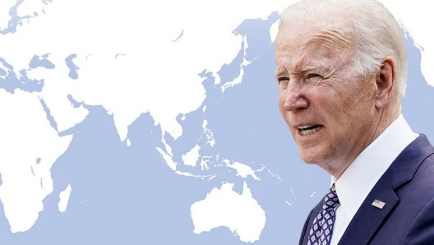
- Modi’s attendance at the event is a significant step towards building economic ties among Quad countries (India, the U.S., Australia and Japan) in the Indo-Pacific.

- But officials were hesitant to bill the IPEF as a counter to the 15-nation Regional Comprehensive Economic Partnership (RCEP) and the 17-nation Trans-Pacific Partnership (TPP) that China is a member of.
- The IPEF would have a “very wide-ranging membership” and the programme was “designed to put workers at the centre with a focus on the digital economy, clean energy transition, infrastructure and resilient supply chains.
- India has not taken a decision on joining the framework, but is keen on understanding the “contours” of the American plan.

INTERNATIONAL TEA DAY
The International Tea Day is observed on May 21 every year to raise awareness of the long history and the deep cultural and economic significance of tea around the world.
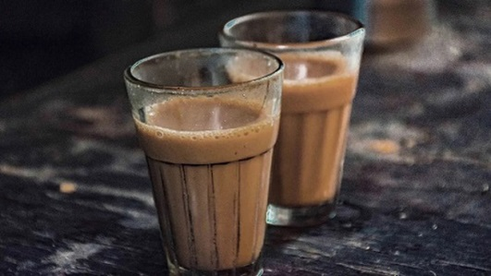
- The first International Tea Day was held in Delhi, India in 2005. It was in 2015 that the Indian Government proposed to the United Nations Food and Agriculture Organisation to expand this day globally.
- The day is observed in the month of May because it is during this time of the year that tea production begins in most countries.
- Tea is believed to have originated from the north-eastern parts of India and south western China. In these regions, tea production is one of the main sources of livelihood.
- The Tea Board of India was established by the enactment of the Tea Act in 1953 with its headquarters in Kolkata. It is under the administrative control of ministry of commerce and industry.
- The Government through the Tea Board is implementing Tea Development and Promotion Scheme (TPDS) which provides financial assistance to the tea industry in the country.

ANTHONY ALBANESE
In Australia, newly elected Labour Party leader Anthony Albanese has been sworn in as Prime Minister.
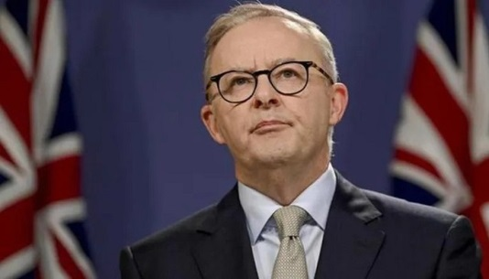
- Outgoing Prime Minister Scott Morrison, who was heading Liberal-National coalition, was defeated in the recent elections.

- Mr Albanese, who will be heading Australia's first Labor government in almost a decade, has vowed a big shift in climate policy.
- Climate change has been a key concern for voters, after three years of record-breaking bushfires and flood events.

