Current Affairs : 22 May 2022

CENTRE SLASHES FUEL TAXES, SETS ₹200 SUBSIDY ON LPG CYLINDERS

- In a slew of measures to control the rising inflation in the economy, the central government recently announced a reduction in the central excise duty on petrol and diesel and Rs 200 subsidy on LPG gas cylinders, among others measures.

Fuel Pricing Mechanism in India:
- Petrol prices were deregulated in 2010 and Diesel prices were deregulated in 2014 i.e. now Oil Marketing Companies (OMCs) determine the prices of these products.
- These prices are not determined by the actual costs incurred by the OMCs such as Indian Oil, HPCL and BPCL on crude oil sourcing, refining and marketing.
- Rather, a formula — Trade Parity Price (TPP) — is used to price these products.

- TPP Formula:
  - TPP is based on the calculation that 80 per cent of petrol and diesel is imported into India and 20 per cent is exported.
  - So, petrol and diesel prices in India are determined based on prices of these fuels in the international market — and not on the basis of crude oil prices.
  - While international petrol and diesel prices generally move in line with crude oil prices, it need not always be the case, given that demand and supply dynamics could be different.
- From June 2017, the pricing of petrol and diesel is done through a daily pricing mechanism, based on a 15-day rolling average international rate.

- Apart from TPP, there are three other factors that determine the price of petrol and diesel in India:
  - Excise duty charged by the Central Government
  - Value-Added Tax (VAT) charged by the State Governments
  - Dealer commission to the gas stations
- While excise duty rates are uniform across the country, states levy sales tax/Value Added Tax (VAT) which varies across states.

How are LPG prices determined?
- Similar to petrol/diesel, prices for LPG (Liquified Petroleum Gas) cylinders are determined by the OMCs.
- The price of LPG is revised in India as per a formula known as import parity price (IPP).
  - Import parity is calculated as the cost of the commodity in the source location, plus the cost of delivery to the destination.
  - The IPP is calculated as per Saudi Aramco’s LPG price, the world’s largest producer.
- The price includes costs like free on board (FOB) price, ocean freight, custom duties, port charges and insurance cost among other things.
- Local freight charges, bottling charges, marketing costs, margins for OMCs, dealer commissions and Goods and Services Tax are also factored in before determining the final LPG retail price in India. In addition, currency fluctuations also affect prices.
- The common practice is to revise the price of LPG cylinders on a month-on-month basis.

Why are Fuel Prices so High?
- Recently, the Finance Minister of India, Nirmala Sitharaman, pointed out two factors due to which the fuel prices are high in India:
  - The ongoing Ukraine-Russia Conflict
  - Oil Bonds offered by the earlier Government

GOVT. WANTS TO KEEP LOOK-OUT CIRCULAR DETAILS UNDER WRAPS
- A series of recent court orders have put emphasis on the opaque and mechanical manner in which look-out circulars (LOCs) are generated.
- Despite the fact that the opaque system is such that a person will not know if such a circular exists against him or her until they arrive at the airport, the Union Home Ministry is not about to back down.

Look-out circulars (LOCs):
  - An LOC is issued to make sure that an individual who is absconding or wanted by law enforcement agencies is not able to leave the country.
  - It is mostly used at immigration checkpoints at international airports and seaports by the immigration branch.

- How and who can issue an LOC?
  - In India, it can be issued by the Ministry of Home Affairs and by various authorities for keeping a watch on arrival or departure of Indians and foreigners.
  - These authorities include the Ministry of External Affairs, the Customs and Income Tax Departments, Directorate of Revenue intelligence, Central Bureau of Investigation, Interpol, Regional Passport Officers, Police authorities, etc.
  - In certain cases, the police can approach a court asking for the restriction of a person’s movement outside the country, when there is an apprehension that they may not join the investigation at a later stage.
  - The subject of an LOC can challenge the circular and get relief from a court.

- Rules to issue an LoC and its validity:
  - An LOC can be initiated by a large number of authorised officers, including an officer not below the rank of deputy secretary to the government of India/joint secretary in the state government/concerned district magistrate or superintendent of police at the district level, et
  - In 2018, the government also empowered the heads of public sector banks to directly request the authorities to issue an LOC against wilful defaulters to prevent them from leaving the country.
  - An LOC is valid for a period of one year and can be extended further before the expiry of the one-year period.
  - An LOC can be modified/deleted/withdrawn by the Bureau of Immigration only on the specific request of the authorised originator on whose request the LOC was issued.

- Does an LOC lead to arrest? (Not necessarily)
  - LOCs can be of several types.
  - They can simply seek to prevent a person named in the circular from leaving the country.
  - The LOC proposal can also include a request to detain the individual at the local police/investigative agency, which usually results in arrest.

- Interpol notices v. LOC:
  - The primary difference between an LOC and an Interpol notice is that an LOC can be issued by Indian investigating agencies to the Indian Immigration Bureau office in New Delhi.
    - The Immigration Bureau then circulates it to the various immigration points in the country and Indian missions abroad.
  - But in case of an Interpol notice, the CBI is the nodal agency and process requests on behalf of its organisations.
  - There are eight types of Interpol notices and among the most commonly known is Red Corner notice.
  - The Red Corner notice is issued to extradite the accused from another country where the person is arrested or detained. The notice, however, doesn’t bind the other country to extradite the accused.

PROJECT WARDEC
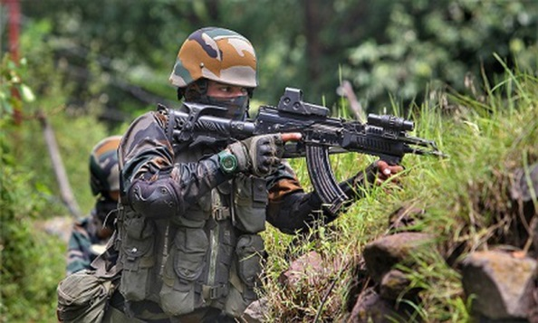
The Army Training Command signed a MoU with Gandhinagar-based Rashtriya Raksha University (RRU) to develop a ‘Wargame Research and Development Centre’ in New Delhi.

- The project, which has been given a prototype name ‘WARDEC’, will be a first-of-its-kind simulation-based training centre in India that will use artificial intelligence (AI) to design virtual reality wargames.
- The Wargame Research and Development Centre will be used by the Army to train its soldiers and test their strategies through “metaverse-enabled gameplay”. The wargame models will be designed to prepare for wars as well as counter-terror and counter-insurgency operations.
- The centre will come up in a military zone in New Delhi. The RRU will join hands with Tech Mahindra to develop the centre in the coming three to four months, officials added.
- The RRU, an institute under the Ministry of Home Affairs (MHA), specialises in national security and policing. Located in Gandhinagar’s Lavad village, it is an “institute of national importance” – a status granted to it by an Act of Parliament.

RETINOBLASTOMA
The World Retinoblastoma Awareness Week was observed from May 15 to 21.
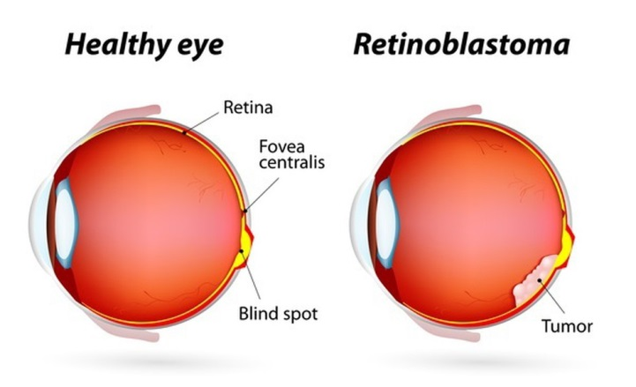
About:
- Retinoblastoma is the most common eye cancer (malignant tumor) occurring in young children.
- It can occur in one or both eyes and may be hereditary or sporadic. It can be life-threatening as well as take away vision if not treated timely and is detected by seeing White Reflex (WR).
- Nearly 1,500-2,000 children are diagnosed with retinoblastoma every year in India.

- Symptoms
  - White Reflex in the eye: Pupil that looks white or yellow instead of red when light hits it.
  - Squinting: A crossed eye, looking either toward the nose or towards the ear.
  - Poor vision with or without WR. The eye may be red or painful also.

- Treatment: Chemotherapy can be delivered intravenously or intra-arterial and is given by the paediatric oncologist and is the most common modality of treatment. This has to be followed up with local therapy, which is managed by the ophthalmologist using various modalities.

BioRRAP
In keeping with the spirit of "One Nation, One Portal", Union Minister of Science and Technology launched Single National Portal for Biotech researchers and Start-ups.
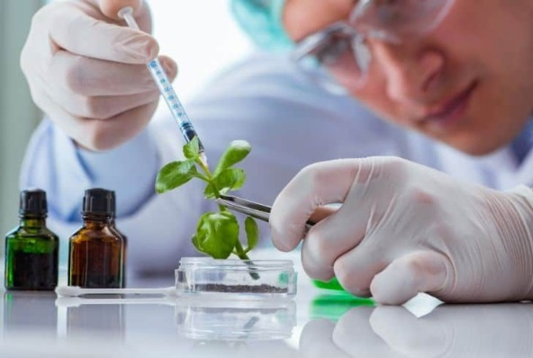
- The Portal "BioRRAP" will cater to all those seeking regulatory approval for biological research & development activity in the country.
- Biological Research Regulatory Approval Portal (BioRRAP) will also allow stakeholders to see the approvals accorded against a particular application through a unique BioRRAP ID.

Do you know?
- India is among the top 12 destinations for biotechnology globally and 3rd largest biotechnology destination in the Asia Pacific region.
- By 2025, the contribution of the Indian biotechnology industry in the global biotechnology market is expected to grow to 19% from a mere 3% in 2017. The Bio Economy’s contribution to the national GDP has also grown steadily in the past years to 2.7% in 2020 from 1.7% in 2017.

SOWA RIGPA
The Union Minister for Ayush announced major initiatives to boost the traditional medicinal practice including Sowa Rigpa, Ayurveda and Naturopathy in the state of Sikkim.
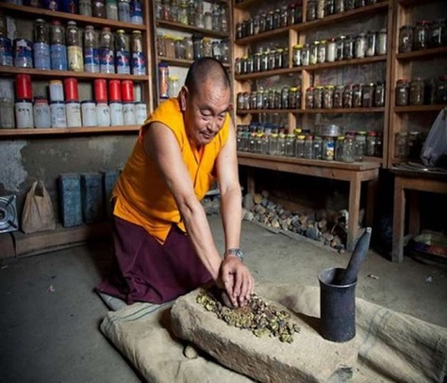
- An International Yoga & Naturopathy College will be set up in Sikkim which will boost the medical tourism sector in the Northeast India.
- A 30 bedded Sowa Rigpa Hospital is going to be set up in Sikkim.
- The Union Minister announced setting up of Yoga & Wellness centre at every Gram Panchayat level in the state along with an Ayurveda Medical College under Satellite Institute programme in Sikkim.
- The Union Ayush Minister also said that the Ministry is exploring the possibility to set up a Research Council for Sowa Rigpa.

- Do you know? “Sowa-Rigpa” commonly known as Amchi system of medicine is one of the oldest living medical tradition of the world. It has been popularly practiced in Tibet, Magnolia, Bhutan, some parts of China, Nepal and Himalayan regions of India.

RAM MOHAN ROY
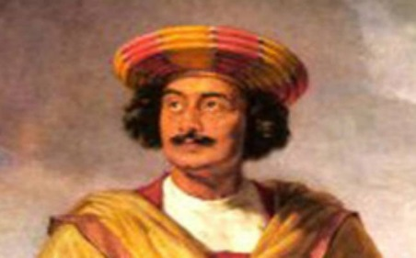
Union Culture Ministry will commemorate the 250th Birth Anniversary of Raja Ram Mohan Roy till 22nd of May next year under the aegis of 'Azadi Ka Amrit Mahotsav'.

- Ram Mohan Roy (1772 – 1833) was an Indian reformer. He is considered to be the "Father of the Bengal Renaissance" by many historians.
- He crusaded against Hindu customs such as sati, polygamy, child marriage and the caste system. He demanded property inheritance rights for women.
- In 1830, Ram Mohan Roy travelled to the United Kingdom as an ambassador of the Mughal Empire to ensure that Lord William Bentinck's Bengal Sati Regulation, 1829 banning the practice of Sati was not overturned.
- He who was one of the founders of the Brahmo Sabha in 1828, the precursor of the Brahmo Samaj, a social-religious reform movement.
- In 1817, in collaboration with David Hare, he set up the Hindu College at Calcutta.
- His most popular journal was the Sambad Kaumudi. It covered topics like freedom of the press, induction of Indians into high ranks of service, and separation of the executive and judiciary.
- He was given the title of Raja by Akbar II, the Mughal emperor.

THE GREAT GAMA
On 22 May 2022, search engine Google commemorated “The Great Gama” with a Doodle on his 144th birth anniversary.
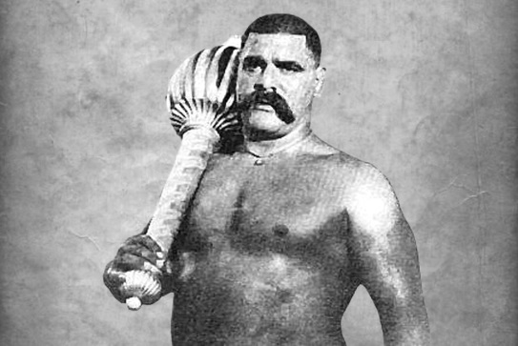
- Ghulam Mohammad Baksh Butt (1878 – 1960), commonly known as Rustam-e-Hind (Rustam of India) and by the ring name The Great Gama, was an Indian pehlwani wrestler and strongman.
- He was Born in village Jabbowal, Amritsar District in the Punjab Province of colonial British India in 1878.
- In the early 20th century, he was an undefeated wrestling champion of the world, and was awarded a version of the World Heavyweight Championship on 15 October 1910.
- Undefeated in a career spanning more than 52 years, he is considered one of the greatest wrestlers of all time.
- During the partition of India, the Great Gama saved the lives of many Hindus and then spent the rest of his days until his death on May 23, 1960 in Lahore, Pakistan.

