Current Affairs : 20 May 2022

INDIA’S ETHANOL BLENDING POLICY

- Government approved amendments to the National Policy on Biofuels, 2018, to advance the date of 20% ethanol blending with gasoline to 2025-26 from 2030.
- The policy of introducing 20% ethanol is expected to take effect from April 1, 2023.
- The proposed amendments are in line with vision of India becoming energy independent by 2047.
- Given the skyrocketing fuel prices, the blending programme has a dual purpose i.e., to reduce the crude oil import bill and to allow consumers access to environment friendly fuel.

Proposed amendments to the National Policy on Biofuels
- Revised target: The main amendment is for advancing the target of blending 20% ethanol in petrol (20% ethanol, 80% petrol), by 5 years to 2025-26 from 2030.
- Additional Feedstock: More feedstocks have been allowed for the production of biofuels which can be doped with autofuels.
- Indigenous production: It also provides for promoting the production of biofuels in the country, under Make in India programme, by units located in SEZ/ Export Oriented Units (EoUs).
- Indigenous technology: The new policy signifies the development of indigenous technologies for ethanol production.
- Exports: The amendment also allows granting of permission for export of biofuels in specific cases.
- Composition: The government has allowed the addition of new members to the National Biofuel Coordination Committee (NBCC).
- NBCC was constituted under the Chairmanship of Minister, Petroleum & Natural Gas (P&NG) to provide overall coordination, effective end-to-end implementation and monitoring of biofuel programme.

National Policy on Biofuels, 2018
- It provided an indicative target of blending 20% ethanol in petrol and 5% biodiesel in diesel by 2030.
- The Policy categorises biofuels as follows:
  - Basic Biofuels First Generation (1G) bioethanol & biodiesel and "Advanced Biofuels".
  - Advance Biofules Second Generation (2G) ethanol from non-food crops, Municipal Solid Waste (MSW) to drop-in fuels.
  - Algae based Third Generation (3G) biofuels, bio-CNG etc. to enable extension of appropriate financial and fiscal incentives under each category.
  - 4G biofuels yet not classified will be from genetically engineered crops
- It expands the scope of raw material for ethanol production by allowing use of Sugarcane Juice, Sugar containing materials like Sugar Beet, Sweet Sorghum, Starch containing materials like Corn, Cassava, Damaged food grains like wheat, broken rice, Rotten Potatoes, unfit for human consumption for ethanol production.
- The Policy allows use of surplus food grains for production of ethanol for blending with petrol with the approval of National Biofuel Coordination Committee.
- The Policy encourages setting up of supply chain mechanisms for biodiesel production from non-edible oilseeds, Used Cooking Oil, short gestation crops.

History of ethanol blending in India
- Since 2001, India has tested the feasibility of ethanol blended petrol whereby 5% ethanol blended petrol (95% petrol5% ethanol) was supplied to retail outlets.
- In 2002, India launched the Ethanol Blended Petrol (EBP) Programme and began selling 5% ethanol blended petrol. However until 2013-14, the percentage of blending never crossed 1.5%.
- Since 2020, India has been announcing its intent to achieve 10% blending by the end of 2022 and 20% blending by 2030.
- Currently, about 10% of ethanol is blended in petrol.

Potential gains of ethanol blended petrol
- Reduce reliability on crude oil: Ethanol can be sourced from sugarcane, molasses, maize, which given India’s agricultural base, can substantially reduce India’s dependence on petroleum.
- Cut import bill: India’s net import of petroleum was 185 million tons at a cost of $55 billion in 2020-21. According to NITI Aayog roadmap for ethanol blending, a successful 20% ethanol blending programme could save the country $4 billion per annum
- Save cost: The government expects to save $6.45 billion in this fiscal year alone (FY23) from ethanol blending.
- Self-sustainability: India being world’s third biggest oil importer and consumer relies on foreign suppliers for about 85% of its fuel demand. Thus, indigenous ethanol blending is pertinent for sustainable development towards Atamnirbhar Bharat.
- Decreased emissions: The roadmap estimated higher reductions in carbon monoxide emissions with E20 fuel i.e., 50 per cent lower in two-wheelers and 30 per cent lower in four-wheelers as compared to unblended petrol.

Challenges concerning ethanol blended petrol
- Less efficacy: It takes much more ethanol to power a vehicle’s engine than petrol. When using E20, there is an estimated loss of 67% fuel efficiency for four wheelers, 34% for two wheelers which are originally designed for E0 and calibrated for E10 and 12% for four wheelers designed for E10 and calibrated for E20.
- Engine retrofitting: Vehicles made in India since 2008 are material-compatible (rubber and plastic components) with E10 (10 per cent ethanol blended in petrol) and fuel-efficient compliant with E5 (5 per cent ethanol blended in petrol), but their engines are not tuned to E10 for optimum performance. At the next stage, when E10 petrol is made available across the country, new vehicles will need engine modifications.
- Increased vehicle cost: The two wheeled flex fuel vehicles would be costlier by ₹5,000 to ₹12,000 compared to regular petrol vehicles.
- A flexible-fuel vehicle (FFV) is an alternative fuel vehicle with an internal combustion engine designed to run on more than one fuel and both fuels are stored in the same common tank.
- Limited supply: The current capacity derived from sugar molasses barely comprises 8 to 9% and is concentrated largely in 3 states - UP, Maharashtra and Karnataka. These are termed as surplus states due to their production in excess of the 10% blending requirement. All other states are deficit.
- Environmental costs:, There is no evidence of reduction in nitrous oxides due to EBP adoption.
- By-Products: Ethanol also leaves residual byproducts that can corrode and damage the vehicle which is why, while vehicles can be run on ethanol, they need to be tuned accordingly.
- Land usuage: A report by the Institute for Energy Economics and Financial Analysis (IEEFA) says that for India to meet its target of 20% ethanol blended in petrol by the year 2025, it will need to bring in 30,000 additional sq km of land to come under maize cultivation.
  - IEEFA contends that half that land can be used more efficiently to produce clean electricity from solar energy and generate renewable energy for Electric Vehicles (EV).
  - For example, an EV charged from solar energy generated on one hectare of land can drive 32 times further than a vehicle running on ethanol derived from one hectare of sugarcane.
- Food insecurity: IEEFA noted that rising manufacturing of food-based raw material for ethanol production could impact food security when India ranks 101 out of 116 nations on the World Hunger Index 2021.
- Water stress: For India, sugarcane is the cheapest source of ethanol. On average, a ton of sugarcane can produce 100 kg of sugar and 70 litres of ethanol but that would mean 1,600 to 2,000 litres of water to produce 1 kg of sugar, implying that a litre of ethanol from sugar requires about 2,860 litres of water, creating water scarcity situation.
- Minimum Support Price: The prices of ethanol produced in India are higher compared to U.S. and Brazil, since the cost of raw materials i.e., sugarcane and food grains are fixed by the government to support farmers, thus limiting EBP adpotion.
- Fund crunch: Many cooperative sugar mills have complained about a fund crunch in operations. Banks are reluctant to finance sugar mills given their weak balance-sheets.

GOVT. FLAGGED LOW SCORE IN WORLD BANK’S GOVERNANCE INDICATORS

- In an analysis of the World Bank’s World Governance Indicators (WGI), a presentation was made by the Ministry of Finance’s Economic Division.
- The presentation found that India’s scores were much below its peers on all counts.

World Bank’s World Governance Indicators (WGI)
- The World Bank’s WGI provide a ranking of 215 countries and territories based on six dimensions of governance:
  - Voice and Accountability;
  - Political Stability and Absence of Violence;
  - Government Effectiveness;
  - Regulatory Quality;
  - Rule of Law and
  - Control of Corruption.

- These aggregate indicators combine the views of a large number of enterprise, citizen and expert survey respondents in industrial and developing countries.
- They are based on over 30 individual data sources produced by a variety of survey institutes, think tanks, NGOs, international organizations, and private sector firms.

Governance: as defined by WGI
- Governance consists of the traditions and institutions by which authority in a country is exercised.
- This includes:
  - the process by which governments are selected, monitored and replaced;
  - the capacity of the government to effectively formulate and implement sound policies; and
  - the respect of citizens and the state for the institutions that govern economic and social interactions among them.

- Freedom House Report 2020
  - 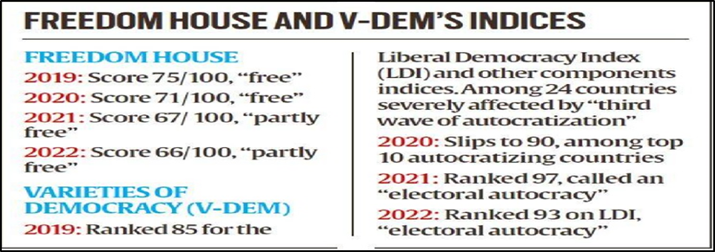
  - It noted that the Freedom House Report 2020 mentions alarming setbacks in the world’s largest democracy.
  - It also highlighted that a series of actions by India’s Hindu nationalist government in 2019 violated democratic rights in India and Indian Kashmir.
  - The presentation said, factors noted in the Freedom House report led to the country receiving the largest score decline among the world’s 25 largest democracies in 2020.

NIKHAT ZAREEN
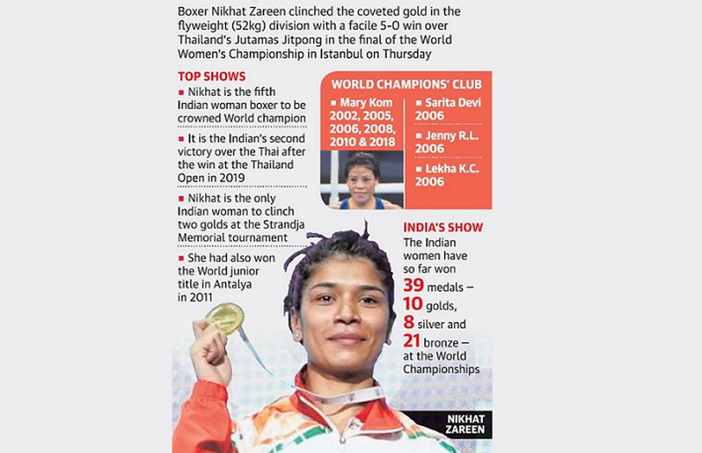
On 19 May 2022, Nikhat Zareen won the gold medal in the 52kg category at the Women's World Championship defeating Thailand's Jitpong Jutamas in the fly-weight final in Istanbul, Turkey.
- Zareen became the fifth Indian women's boxer to win a gold medal at the World Championships, joining Mary Kom, Laishram Sarita Devi, Jenny R. L., and Lekha K. C..
- Nikhat Zareen (born 1996) is an Indian amateur boxer born in Nizamabad, Telangana.
- She won gold medal at the International Boxing Association (amateur) Women's Youth & Junior World Championships Antalya 2011.

DEPRECIATION OF THE RUPEE
The rupee closed at a record low of 77.72 against the dollar, a loss to over 6% in the last one year as it gets weighed down by rising inflation, interest rates, exit of foreign investors and plunging markets.
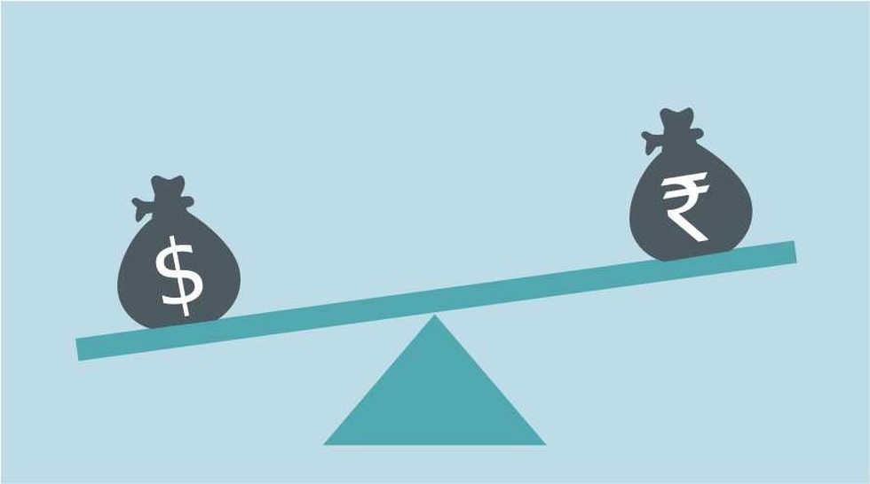
Since the time Russia invaded Ukraine, the rupee has depreciated about 4% cent while currencies in other emerging markets have depreciated 4-7%.
- The rupee has been hitting fresh all-time lows of late due to a rise in the dollar index and concerns around global economic growth.
- Domestically, we are witnessing an outflow of funds as investors move funds to high-yielding investment instruments.
- Rising import costs and a growing current account deficit have been key reasons for the weakening of the rupee. India’s merchandise trade deficit widened to $20.1 billion in April.
- The depreciation is expected to impact the economy in general and various segments such as imports, mainly fuel prices, and push up inflation.

INTEROPERABLE CARD-LESS CASH WITHDRAWAL (ICCW) AT ATMs
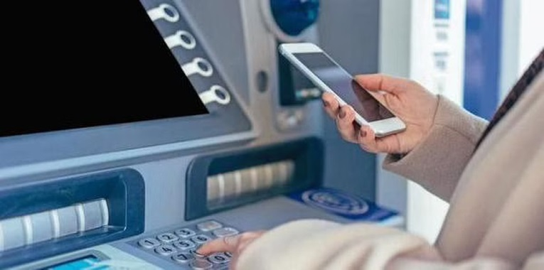
Reserve Bank of India has directed banks and ATM operators to provide cardless cash withdrawal facilities at all ATMs.

- In a circular, the RBI said, all banks, automated teller machine (ATM) networks, and White Label ATM Operators (WLAOs) may provide the option of ICCW at their ATMs.
- The National Payments Corporation of India (NPCI) has been advised to facilitate Unified Payments Interface (UPI) integration with all banks and ATM networks.
- The RBI said, while UPI would be used for customer authorization in such transactions, settlement would be through the National Financial Switch (NFS) and ATM networks.
- The on-us and off-us ICCW transactions shall be processed without levy of any charges other than those prescribed under the circular on Interchange Fee and Customer Charges, it added.
- In a bid to check fraud, RBI last month said, it has been decided to permit all banks to introduce card-less cash withdrawal through ATMs. According to the central bank, currently, cardless cash withdrawal through ATMs is offered by a few banks.
- A transaction carried out at an ATM of the card-issuing bank is called an On-Us transaction. A transaction carried out at any other ATM is called an Off-Us transaction.

