Current Affairs : 19 May 2022

4 KEY CLIMATE CHANGE MARKERS HIT RECORD HIGHS LAST YEAR: UN
In its recently released ‘State of Climate’ report, the World Meteorological Organisation (WMO) noted that four key climate change indicators - greenhouse gas (GHG) concentrations, rise in sea level, ocean heat and ocean acidification, set new records in 2021.

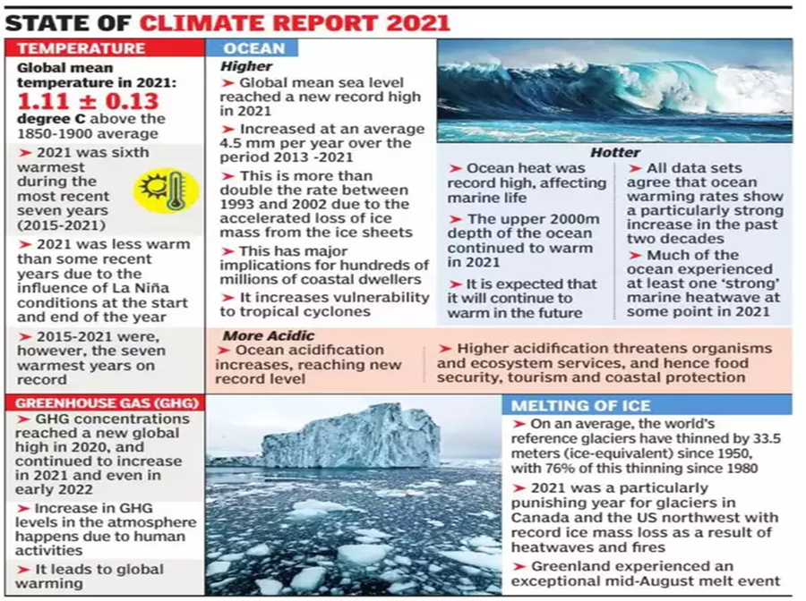
The ‘State of Climate’ report:

- Highlights:
  - The last seven years (2015-21), were globally the warmest years on record, and the average global temperature last year was about 1 degree Celsius above the pre-industrial level (1850-1900).
    - The annual average global temperature has a 50:50 chance of temporarily exceeding 1.5°C over pre-industrial levels in at least one of the next five years.
    - The year 2021 was slightly less warm due to a La Nia (cooler than normal seas in the tropical Pacific Ocean) event at the start and end of the year, but this did not reverse the overall trend of rising temperatures.
  - The global mean sea level reached a new record high in 2021, rising an average of 4.5 mm per year over the 2013-2021 period.
    - It increased at more than double the previous rate due to accelerating loss of ice mass, making people in coastal areas more vulnerable.
    - Some glaciers have reached the point of no return, which will have long-term consequences in a world where more than two billion people already face water scarcity.
    - For example, cyclonic events such as Tauktae and Gulab and floods in India have resulted in displacement of more than one lakh people last year.

- Concerns and suggestions:
  - The report is a terrible record of humanity's failure to address climate change.
  - This is a clear indication of how global warming will be deadly for coastal communities, as the catastrophic level of 1.5 degrees Celsius rise is not far away.
  - Such indicators affect not just human population along the coasts but also marine life endangering biodiversity and food security.
  - According to the UN secretary general -
    - Fossil fuels are a dead end - environmentally and economically, and we must end fossil fuel pollution and accelerate the renewable energy transition.

FREEDOM AT MIDLIFE FOR RAJIV KILLING CONVICT
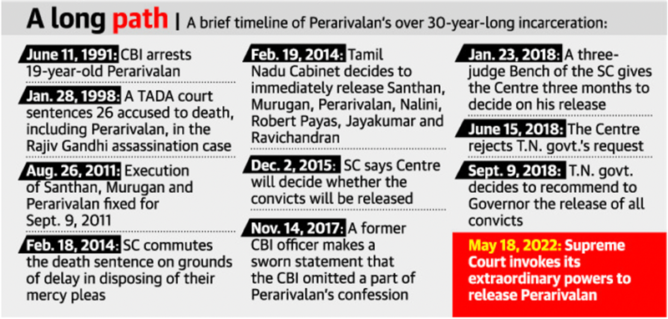
- The Supreme Court on Wednesday invoked its extraordinary powers to do complete justice under Article 142 of the Constitution and ordered the release of A.G. Perarivalan in former Prime Minister Rajiv Gandhi assassination case.

- In 2014, the Supreme Court had commuted the death sentence of AG Perarivalan, convict in the Rajiv Gandhi assassination case, to life imprisonment on account of the undue and unexplained delay in deciding his mercy plea.
- Subsequently in 2018, Perarivalan submitted an early release application to the Governor (Tamil Nadu) under Article 161 of the Constitution.
- Thereafter, the Governor had kept his plea in abeyance for quite some time.
  - Meanwhile, the Governor decided to refer the plea to the President.
- The Tamil Nadu government objected to such ‘reference’, which has no statutory or constitutional validity.
- Both, Perarivalan and the Tamil Nadu government, in 2018, approached the Supreme Court due to the delay in his release, despite a recommendation given by the then Tamil Nadu government to remit his sentence.

Supreme Court’s Judgement:
- The Supreme Court ordered the release of Perarivalan, invoking powers under Article 142 of the Constitution.
- The court was of the view that the inordinate delay in deciding Perarivalan's early release plea by the Governor under Article 161 warranted his release.
- The court opined that the state government is well-within its authority to aid and advise the Governor in pardon/remission pleas pertaining to cases of murder.

Article 142 of the Constitution:
- Article 142 provides a unique power to the Supreme Court, to do “complete justice” between the parties, where at times law or statute may not provide a remedy.
- In those situations, the Court can extend itself to put a quietus (soothing effect) to a dispute in a manner that would fit the facts of the case.
- The necessity for incorporating such an article into the Constitution was spelt out in the Constituent Assembly.
- The framers of the Constitution felt that this provision is of utmost significance to those people who have to suffer due to the delay in getting their necessary reliefs due to the disadvantaged position of the judicial system.

Important instances where the Supreme Court exercised its powers under Article 142:
- Union Carbide Corporation v. Union of India:
  - In Bhopal Gas Tragedy Case, the court ordered to award compensation to the victims and placed itself in a position above the Parliamentary laws.

Article 161 of the Constitution:
- Under Article 161, the Governor of a state possesses the pardoning power.
- A Governor can grant pardons, reprieves, respites and remissions of punishment or suspend, remit and commute the sentence of any person convicted of any offence against a state law.
- The advice of the state cabinet is binding on the Governor in matters relating to commutation /remission of sentences under Article 161.
- Also, the orders passed by the Governor, under Article 161, can be subjected to judicial review.

NORTH ATLANTIC TREATY ORGANIZATION (NATO)
Finland and Sweden submitted a joint application to join NATO as Russia's invasion of Ukraine forces a dramatic reappraisal of security in Europe.
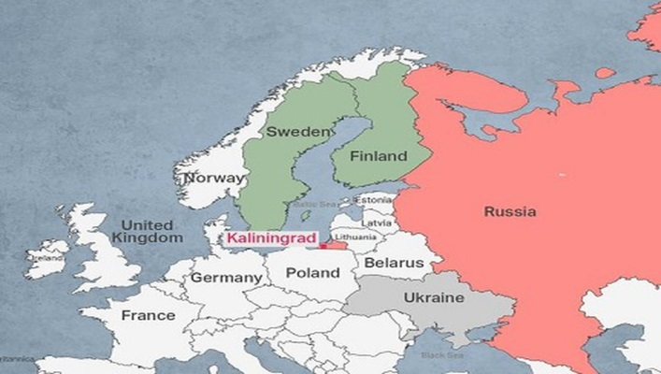
The North Atlantic Treaty Organization (NATO) is an intergovernmental military alliance between 30 member states – 28 European states, the United States, and Canada.
- The organization, headquartered in Brussels, implements the North Atlantic Treaty, which was signed on 4 April 1949.
- The reversal of the Nordic countries' long-standing policy of non-alignment came amidst the Ukraine-Russia conflict. The membership push could represent the most significant expansion of NATO in decades, doubling its border with Russia.
- But the applications face resistance from NATO member Turkey, which accuses the Nordic neighbours of harbouring anti-Turkish extremists.

MULTI-AGENCY CENTRE (MAC)
The Union Home Ministry has sanctioned ₹138.48 crore to the Intelligence Bureau (IB) for a “technical upgrade”.
The funds are meant to upgrade the multi-agency centre (MAC), a common counter-terrorism grid under the IB conceptualised in 2001 after the Kargil war.
- The idea behind the MAC was to create an institutional memory on terrorism and act as a platform to analyse the information on terror-related activities.
- The MAC had the main server in Delhi which is linked to the subsidiary multi-agency centre (SMAC) under the Subsidiary Intelligence Bureau (SIBs) in all States, which further disseminates information to the intelligence branch or wing of the respective State police forces.
- Plans are now afoot to link it to the district office of the Superintendent of Police which has been pending for more than a decade now. If MAC is linked to the district SP’s office, relevant information on terror can be fed in the system leading to the expansion of terror database.
- As many as 28 organisations including the Research and Analysis Wing (R&AW), armed forces and State police are part of the platform and various security agencies share real time intelligence inputs on MAC.

SELA TUNNEL PROJECT
The strategically-significant Sela Tunnel project in Arunachal Pradesh is nearing completion.
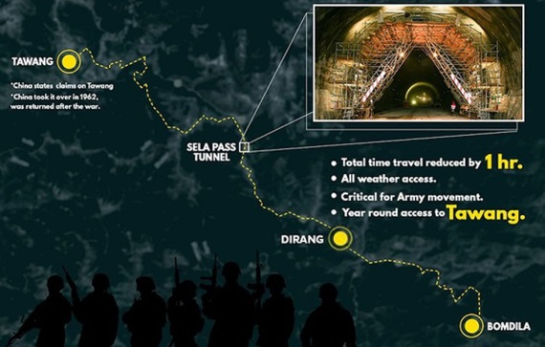
Located in West Kameng district of Arunachal Pradesh, the tunnel project will provide an alternate axis to the Sela pass, which is at 13,700 feet. It will be on the BCT Road – the Balipara, Charduar and Tawang axis, which is more than 300 km long.

  - The project, being executed by the Border Roads Organisation, includes two tunnels and a link road.
  - While Tunnel 1 will be 980 metres long single-tube, Tunnel 2 will be 1,555 metres with one bi-lane tube for traffic and one escape tube for emergencies running alongside.
  - The link road between the two tunnels will be 1,200 metres. Tunnel 2 will be one of the longest tunnels to have been constructed above an altitude of over 13,000 feet.

- Significance: Upon completion, which is likely by the end of this year, the Sela Tunnel above 13,000-ft will boost all-weather connectivity to the Line of Actual Control with China.

