Current Affairs : 16 May 2022

ENDOSULFAN
The Supreme Court has slammed the Kerala government for doing “virtually nothing” for endosulfan pesticide exposure victims. This amounted to a breach of the top court’s 2017 judgment, which had ordered it to pay ₹5 lakh each to the victims in three months.

About:

- What is it? Endosulfan is an organochlorine pesticide that is being phased out globally.

- Health and environment impact: Endosulfan became a highly controversial agrichemical due to its acute toxicity, potential for bioaccumulation, and role as an endocrine disruptor.

- Global scenario: Because of its threats to human health and the environment, a global ban on the manufacture and use of endosulfan was negotiated under the “Stockholm Convention on Persistent Organic Pollutants” in 2011. The ban has taken effect in 2012.

- Indian scenario: Supreme Court passed an interim order in 2011 in the backdrop of the incidents reported in Kasargode, Kerala, and banned the production, distribution and use of endosulfan in India.

TELECOM REGULATORY AUTHORITY OF INDIA (TRAI)
Prime Minister Narendra Modi will address a programme marking silver jubilee celebrations of Telecom Regulatory Authority of India (TRAI) on 17 May, 2022.

About:
- TRAI was established in 1997 through the Telecom Regulatory Authority of India Act, 1997.
- It is the regulator of the telecommunications sector in India.
- The TRAI Act was amended by an ordinance, effective from 24 January 2000, establishing a Telecom Disputes Settlement and Appellate Tribunal (TDSAT) to take over the adjudicatory and disputes functions from TRAI.

5G Test Bed
- During the programme, Prime Minister will also launch a 5G Test Bed, developed as a multi institute collaborative project by a total of eight institutes led by IIT Madras.
- The Test Bed will enable a supportive ecosystem for Indian industry and startups which will help them validate their products, prototypes, solutions and algorithms in 5G and next generation technologies.

KANHERI CAVES
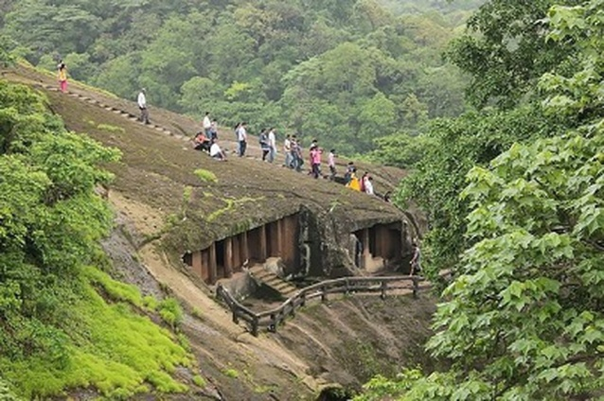
Union Minister of Tourism, Culture and DoNER inaugurates amenities at ancient Kanheri Caves on the occasion of Buddha Purnima.

About:
- The Kanheri Caves are a group of caves and rock-cut monuments cut into a massive basalt outcrop in the forests of the Sanjay Gandhi National Park, on the former island of Salsette in the western outskirts of Mumbai.
- The Kanheri caves comprise more than 110 different rock-cut monolithic excavations and is one of the largest single excavations in the country.
- These excavations were primarily undertaken during the Hinayana phase of Buddhism but also has several examples of the Mahayana stylistic architecture as well as few printings of the Vajrayana order.
- The name Kanheri is derived from ‘Kanhagiri’ in Prakrit and occurs in the Nasik inscription of the Satavahana ruler Vasisthiputra Pulumavi.
- They contain Buddhist sculptures and relief carvings, paintings and inscriptions, dating from the 1st century CE to the 10th century CE.
- Kanheri was mentioned in the travelogues of foreign travelers. The earliest reference of Kanheri is ascribed to Fa-Hein who visited India during 399-411 CE.

THE PLACES OF WORSHIP (SPECIAL PROVISIONS) ACT, 1991
The Supreme Court will hear a challenge to the order of a civil court in Varanasi directing a videographic survey of the Maa Shringar Gauri Sthal in the Kashi Vishwanath temple-Gyanvapi mosque complex.

About:
- Section 3 of the Act bars the conversion, in full or part, of a place of worship of any religious denomination into a place of worship of a different religious denomination — or even a different segment of the same religious denomination.
- Section 4(1) declares that the religious character of a place of worship “shall continue to be the same as it existed” on August 15, 1947.
- Section 4(2) says any legal proceeding with respect to the conversion of the religious character of any place of worship existing on August 15, 1947, pending before any court, shall abate — and no fresh suit or legal proceedings shall be instituted.
- The proviso to this subsection saves suits, appeals and legal proceedings that are pending on the date of commencement of the Act, if they pertain to the conversion of the religious character of a place of worship after the cut-off date.
- Section 5 stipulates that the Act shall not apply to the Ramjanmabhoomi-Babri Masjid case, and to any suit, appeal or proceeding relating to it.

RAMGARH VISHDHARI WILDLIFE SANCTUARY
The Ramgarh Vishdhari Sanctuary in Rajasthan was notified as India's 52nd tiger reserve, Union Environment Minister Bhupender Yadav said.

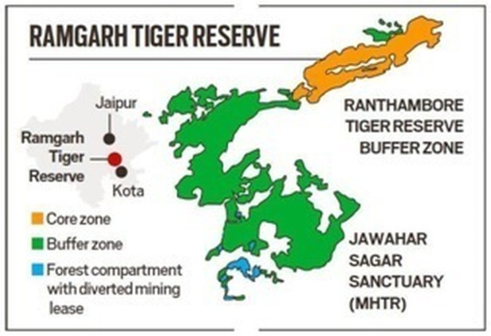
About:
- This is Rajasthan's fourth tiger reserve after Ranthambore, Sariska and Mukundra.
- Ramgarh Vishdhari Wildlife Sanctuary and adjoining areas as tiger reserves on July 5 last year.
- The newly notified tiger reserve includes the tiger habitat between Ranthambore Tiger Reserve in the northeast and Mukundra Hills Tiger Reserve on the southern side and facilitates dispersal of tigers from Ranthambore Tiger Reserve.
- According to "Status of Tigers in India" report released in 2019, there are 2,967 tigers in 20 states across the country.

INDIA-NEPAL AGREEMENTS
India and Nepal signed and exchanged six Memorandum of Understandings and Agreements after bilateral talks between Prime Minister Narendra Modi and his Nepalese counterpart Sher Bahadur Deuba in Lumbini.
Lumbini is the place where Prince Siddhartha Gautama was born around 623 BC. He later attained enlightenment at Bodhgaya in Bihar district and came to be known as the Buddha.

List of MoUs/Agreements signed and exchanged during Prime Minister's visit to Nepal:
- MoU between Indian Council of Cultural Relations (ICCR) and Lumbini Buddhist University on the establishment of Dr. Ambedkar Chair for Buddhist Studies
- MoU between Indian Council of Cultural Relations (ICCR) and CNAS, Tribhuvan University on the establishment of ICCR Chair of Indian Studies
- MoU between Indian Council of Cultural Relations (ICCR) and Kathmandu University (KU) on the establishment of the ICCR Chair of Indian Studies
- MoU in collaboration between Kathmandu University (KU), Nepal and Indian Institute of Technology Madras (IIT-M), India
- Letter of Agreement (LoA) between Kathmandu University (KU), Nepal and Indian Institute of Technology (IITM), India [ For Joint degree program at Master’s level]
- Agreement between SJVN Ltd and Nepal Electricity Authority (NEA) for Development and implementation of Arun 4 Project

ASSAM’S NRC NOT FINAL, FOREIGNERS’ TRIBUNALS TOLD

- Recently, the State Coordinator of the National Register of Citizens (NRC) reminded members of Foreigners' Tribunals (FTs) across Assam not to rely on the draft NRC and its supplementary list as reliable evidence for case disposal.
- A Foreigners' Tribunal is a quasi-judicial body entrusted with determining the citizenship status of those accused of being or labelled as foreigners.

National Register of Citizens (NRC):
- About NRC:
  - At its core, the NRC is an official record of those who are legal Indian citizens. It is mandated by the 2003 amendment of the Citizenship Act, 1955 (governs conditions by which a person holds Indian citizenship).
  - It includes demographic information about all the legal citizens of India so that the illegal immigrants can be identified and deported.
  - So far, such a database has only been maintained for the state of Assam. However, the Home Minister of India recently declared during a parliamentary session that the register would be extended to the entire country.

- Why was NRC updated for Assam?
  - A writ petition had been filed before the Supreme Court (SC) of India demanding the deletion of illegal migrants' names from voter lists in Assam.
  - In 2014, the SC ordered the updating of the NRC, in accordance with Citizenship Act, 1955 and Citizenship Rules, 2003 in all parts of Assam.
  - The NRC in Assam targeted illegal immigrants. An individual had to demonstrate that they or their ancestors were in Assam on or before March 24, 1971.
  - The process officially started in 2015 and the updated final NRC was released on August 31, 2019, with over 1.9 million applicants failing to make it to the NRC list.
  - Following concerns about the removal of numerous Hindus from the list, the Home Ministry said that the NRC would be conducted again in Assam.

About Foreigners’ Tribunals (FT):
- These are quasi-judicial bodies (whose members are like a judge) established as per the Foreigners’ Tribunal Order, 1964 and the Foreigners’ Act, 1946.
- It is for people who were not included in the final NRC list or were tagged as 'D,' which stands for 'doubtful.'
- Those who fall under this group have the right to file an appeal with the Foreigners Tribunal.
- Only Foreigners Tribunals have the authority to declare a person a foreigner under the terms of the Foreigners' Act of 1946 and the Foreigners Tribunal Order of 1964.
- Thus, the absence of a person's name from the NRC does not imply that he or she is a foreigner.
- According to the Government of Assam's website, there are 100 Foreigners Tribunals in operation in Assam.

News Summary:
- The State Coordinator had sent letters to FT members stating that because the Registrar General of Citizens Registration (RGCR) had not proclaimed the NRC as complete and there were inaccuracies, things could change once the final NRC was published.
- An FT member stated that the NRC was final and was published in accordance with several SC orders and judgments and through a notification of the RGCR.
- The member asked the State Coordinator to withdraw letter and refrain from interfering with the lawful operation of the Foreigners' Tribunals, which is outside his jurisdiction and power.
- About 06 lakh out of 3.3 crore applicants were excluded from the complete NRC draft published on August 31, 2019.
- Only the RGI (Registrar General of India) and the State Coordinator is authorised to publish the final NRC, which is yet to be done.

ONLY ONE STATE CAN DECIDE ON REMISSION
In News:
- The Supreme Court, in a judgment, said that there cannot be a concurrent jurisdiction of two State governments on the issue of remission.

Pardon and remission
Scope
- Both the President and the Governor have been vested with sovereign power of pardon by the Constitution.
- Under Article 72, the President can grant pardons, reprieves, respites or remissions of punishment or suspend, remit or commute the sentence of any person.
- This can be done for any person convicted of any offence in all cases where the punishment or sentence is:
  - by a court-martial,
  - for an offence under any law relating to the Union government’s executive power, and in all cases of death sentences.
- Under Article 161, a Governor can grant pardons, reprieves, respites or remissions of punishment, or suspend, remit or commute the sentence.
  - This can be done for anyone convicted under any law on a matter which comes under the State’s executive power.

Statutory power of remission
- The Code of Criminal Procedure (CrPC) provides for remission of prison sentences, which means the whole or a part of the sentence may be cancelled.
- Under Section 432, the ‘appropriate government’ may suspend or remit a sentence, in whole or in part, with or without conditions.
  - Under Section 433, any sentence may be commuted to a lesser one by the appropriate government.
- This power is available to State governments so that they may order the release of prisoners before they complete their prison terms.

Statutory power of remission Vs. Constitutional power of remission
- The power of remission under the CrPC is different from the constitutional power enjoyed by the President and the Governor.
- Under the CrPC, the government acts by itself.
- Under Article 72 and Article 161, the respective governments advise the President/Governor to suspend, remit or commute sentences.
- Despite the fact that it is ultimately the decision of the government in either case, the Supreme Court has made it clear that the two are different sources of power.
  - In Maru Ram etc. vs Union of India (1980), the SC said: Section 432 and Section 433 of the CrPC are not a manifestation of Articles 72 and 161 of the Constitution but a separate, though similar, power.

Background:
- SC was hearing a plea by a convict seeking direction to the State of Gujarat to consider his application for premature release under the policy dated July 9, 1992.
  - This policy was existing at the time of his conviction.
- Though the crime was committed in Gujarat, the top court in 2004 had transferred the case to Mumbai.

News Summary
- Remission or premature release of a convict has to be considered in terms of the policy applicable in the State where the crime was committed and not where the trial was transferred to and concluded.
- This was stated by the apex court while deciding on the concurrent jurisdiction of two State governments on the issue of remission.

THOMAS CUP
India won its first ever Thomas Cup title after beating title holders Indonesia 3-0 in the 2022 edition.

About:
- The Thomas Cup, sometimes called the World Men's Team Championships, is an international badminton competition among teams representing member nations of the Badminton World Federation (BWF), the sport's global governing body.
- The first tournament was held in 1948–1949. The Thomas Cup competition was the idea of Sir George Alan Thomas, a highly successful English badminton player of the early 1900s, who was inspired by tennis's Davis Cup.
- The championships have been conducted every two years.

