Current Affairs : 09/10.05.2022

CYCLONE ASANI
Severe cyclonic storm ‘Asani’, which is moving towards the east coast, packing winds bove 105 kmph and setting off heavy rain, is likely to recurve in a north-eastward direction and weaken gradually into a cyclonic storm, the India Meteorological Department (IMD) said.
Asani is unlike cyclones Fani (April-May 2019) or Amphan (May 2020)
- Systems formed over the Bay of Bengal in the peak of summer in May are among the strongest in the North Indian Ocean region. Warm seas present ripe conditions for cyclogenesis, and to fuel these systems over the water.
- The ‘Extremely Severe’ cyclone Fani and ‘Super cyclone’ Amphan wreaked havoc in Odisha and West Bengal respectively. Cyclone Asani by contrast, is expected to only graze the coast, and not make landfall.

HOW ARE CYCLONES NAMED?
Cyclone Asani, which developed over southeast regions of Bay of Bengal and intensified into a ‘severe cyclone’, was named by Sri Lanka. Asani means “wrath” in Sinhalese.
About:
- In 2000, a group of nations called WMO/ESCAP (World Meteorological Organisation/United Nations Economic and Social Commission for Asia and the Pacific) decided to start naming cyclones in the region.
- After each country sent in suggestions, the WMO/ESCAP Panel on Tropical Cyclones (PTC) finalised the list.
- The list of 169 cyclone names released by IMD in April 2020 were provided by these countries — 13 suggestions from each of the 13 countries.
What are the guidelines to adopt names of cyclones?
- The proposed name should be neutral to (a) politics and political figures (b) religious believes, (c) cultures and (d) gender.
- It should be short, the maximum length of the name will be eight letters.
- The names of tropical cyclones over the north Indian Ocean will not be repeated. Once used, it will cease to be used again. Thus, the name should be new.

MPLADS (MP LOCAL AREA DEVELOPMENT SCHEME).
At a time when MPs have been asking for an increase in the MP Local Area Development Scheme (MPLADS) fund, the Union Finance Ministry has ordered revised rules, under which the interest that the fund accrues will be deposited in the Consolidated Fund of India.

- The order of the Ministry dated April 11 was conveyed to the Rajya Sabha and the Lok Sabha only by the last week of April.
- Each MP is allocated ₹5 crore annually under the scheme.
- The MPLADS fund is released to the district authority and the MPs only have power to recommend development work. The payment is also released by the designated district authority on completion of the work.
- So far, the interest accrued on the fund used to be added to the MPLADS account and could be used for the development projects.
- Opposition parties criticized the changed guidelines, arguing that the new order was in violation of the MPLADS guidelines of 2016.

COUNTING INDIA’S COVID DEATHS
Context
- World Health Organisation (WHO) recently estimated 4 lakh Covid deaths in India in 2020 and 2021 which is nearly ten times the country’s official Covid death toll of 4.81 lakh at the end of 2021.
- According to WHO, this estimate is also nearly one-third of WHO's estimate of all Covid deaths globally (15 million), which then naturally pushes up global figures.
India’s objection
India has rejected the WHO report calling it “statistically unsound and scientifically questionable” on following grounds to dispute the findings:
- The government objected to WHO's modelling approach, which was reserved for Tier II countries like India for which national and sub-national level data wasn’t available.
- India opposed WHO’s usage of data from 17 states ‘based on some websites and media reports’.
- WHO study has relied, among various sources, on monthly Civil Registration System (CRS) death data, which itself ‘provisional’ and subject to change. Only the numbers mentioned in the annual CRS report, released recently are final.

About CRS (Civil Registration System)
- CRS has a long history dating back to the mid-19 century. A Central Births, Deaths, and Marriages Registration Bill was passed in 1886 to allow for consensual registration across British India.
- The Registration of Births and Deaths Act (RBD Act) was passed in 1969 after independence to improve consistency and comparability in the recording of births and deaths throughout the nation, as well as the compilation of vital statistics based on them.
- The CRS is a record of all deaths, births and stillbirths, but does not categories deaths by causes.
RGI (Registrar General of India) is empowered under Section 3(3) of the Registration of Births and Deaths (RBD) Act, 1969 to take steps to coordinate and unify the activities of Chief Registrars of Births and Deaths of all States.
- WHO used its own ‘Global Health Estimate 2019’, which by name is an estimate.
  - India objected to WHO taking a “one size fits all” approach for a country like India as it did not capture variations in test positivity and severity.
  - WHO’s modelling method fails to take into account the variability in Covid positive rate both in terms of area and time within the country.
  - The model also fails to account for the influence of various diagnostic procedures (RAT/RT-PCR) utilised in different geographies.

- The assumption of an inverse relationship between monthly temperature and monthly average deaths does not have any scientific backing to establish such a peculiar empirical relationship.
Credibility of WHO data
- The WHO said it developed an ‘innovative’ and ‘robust’ methodology for its findings that are completely transparent.
- WHO's defence for using a mathematical model is their claim that many countries "still lack capacity for reliable mortality surveillance and therefore do not collect and generate the data needed to calculate excess mortality".
- However, accuracy of computer modeling results depends on the underlying quality of data and assumptions. Slight changes in assumptions or input data can significantly alter results.
- For example, if mortality from Kerala or Maharashtra is extrapolated for the whole country, it would be wrong because those two states saw high mortality throughout the year. Or, if data from the peak of the second wave is extrapolated for the entire country over the two years, it will give an unusually high number.
- Moreover, scientists admit that they still do not fully understand the nature and behaviour of this virus. It is thus difficult to assume that these processes and behaviours that epidemiologists have not fully understood have somehow found accurate description in modelling or machine learning algorithms.
Key Factors
- The WHO report, has estimated the total number of people who likely died in India in 2020 due to all causes and, from that, has subtracted the expected number of all-cause deaths if there was no Covid. These ‘excess deaths’ are considered to be a direct or indirect result of Covid-19.
- But some key factors which play a crucial role in estimating disease-specific deaths are attribution, quality of registries and segregation of deaths due to other factors.
- Attribution: Covid hits people with co-morbid conditions the most. It is difficult to attribute if the death was due to Covid or the co-morbid condition.
- Quality registry system of births and deaths is also not uniform in every state, especially remote districts of India.
- Segregation: Also, during the period of lockdown, people who were already fighting deadly diseases such as tuberculosis, their diagnosis of treatment got delayed as they did not want to move out due to the fear of infection. A section of the population witnessed such deaths as well.
The Official Count
- The actual death data is revealed by the Sample Registration Survey (SRS) whose report for 2020 has not yet been released.
  - SRS is a demographic survey for providing reliable annual estimates of infant mortality rate, birth rate, death rate and other fertility and mortality indicators at the national and sub-national levels. It was initiated on a pilot basis by the Registrar General of India in a few states in 1964-65, it became fully operational during 1969-70.

- The CRS is a database of all births and deaths that get It thus only has death registration data, and not every death in the country is registered.
- CRS is a subset of SRS
  - SRS uses a door-to-door survey in a few thousand sample towns and villages to produce an estimate of the total number of births and deaths in the country every year and also repeated after a few months to avoid duplication.

- Over the last few years, as more and more people are registering their births and deaths, the CRS numbers are converging closer to the SRS estimates.
- These two systems might still not be perfect, but they are extremely robust sources of birth and death data. These data are consistent with the findings of the Census and a vast array of other data-collection exercises that together make up all the demographic, social and economic indicators that everyone agrees on.
Therefore any discussion on the undercount as of now is premature because India has not yet stopped counting its Covid deaths and the number is under constant revision. The states have also been updating and making similar adjustments to Covid death data every day.
A physical count, and verification, of the dead in a country as vast as India during such chaotic times is bound to take a little more time than running some equations in a computer model. However, the sobering data points to the need for all countries to invest in more resilient health systems that can sustain essential health services during crises, including stronger health information systems.

PRESIDENTIAL POLL: VALUE OF VOTE OF MPS LIKELY TO GO DOWN TO 700 FROM 708
(Lok Sabha Seats – 543, Rajya Sabha Seats – 233, Total – 776)
In News:
- Due to the absence of a legislative assembly in Jammu and Kashmir (J&K), the value of a Member of Parliament (MP) vote is likely to fall from 708 to 700 in the presidential elections scheduled for July.
Presidential Election:
- Overview:
  - Under the Constitution of India (Article 52), there shall always be a President of India, holding the highest elective office in the country.
  - The President holds office for a period of five years from the date on which s/he enters upon her/his office. Accordingly, an election is held before the expiration of the term of the incumbent President.
  - S/he is elected in accordance with the provisions of the Constitution and the Presidential and vice-Presidential Elections Act, 1952. The said Act is supplemented by the provisions of the Presidential and Vice-Presidential Elections Rules, 1974.
  - Therefore, the President is elected by an Electoral College (Article 54), which consists of the elected members of both Houses of Parliament and the elected members of the Legislative Assemblies of all the States and also UTs of NCT of Delhi and Puducherry (now J&K also).
  - Under Article 324 of the Constitution of India, the authority to conduct elections to the Office of President is vested in the Election Commission of India (ECI).
  - As per Article 55(3) of the Constitution of India, the election of the President shall be held in accordance with the system of proportional representation by means of single transferable vote and the voting at such election shall be by secret ballot.
- Process of election:
  - Nomination:
    - Each candidate considering a run for the President of India's office was supposed to file their nominations.
    - Candidates were also asked to pay a deposit of Rs 15,000 and submit a signed list of 50 proposers and 50 seconders.
    - The proposers and seconders can be any of the electors eligible to vote in the Presidential election.
Voting:
    - All elected MLAs (in their respective state and UT capitals) and all elected MPs (at Parliament) will be given ballot papers to cast their vote.
    - Each ballot paper will contain the name of all candidates who are contesting the Presidential election.
    - The electors will proceed to indicate their preference for each candidate.
    - An elector is not required to mark preferences for all Presidential candidates. S/he has to only mark their first preference for their vote to be considered in the election.
  - Value of votes : The value of the vote of a Member of Parliament has been fixed at 708 since the 1997 presidential election.
  - Counting votes:
    - The total number of votes that a Presidential candidate garners is calculated by adding up the value of all the ballots in which a particular candidate receives a first preference.
      - The value of each ballot paper depends on who cast the votes. For example, in 2017 Presidential election, the ballot paper of a UP MLA will be valued at 208, of an Andhra Pradesh MLA at 159 and of an MLA from Sikkim at 7.
      - The value of the ballot paper of any MP (from Rajya Sabha or Lok Sabha) is 708.
    - Deciding the winner:
      - The winner of the Presidential election is the person who gets more votes than a certain quota.
      - The quota is decided by adding up the votes polled for each candidate, dividing the sum by 2 and adding '1' to the quotient.
News Summary:
- Before it was bifurcated into two UTs of Ladakh and J&K (in August 2019), the erstwhile state of J&K had 83 assembly seats.
- According to the Jammu and Kashmir Reorganisation Act, the UT of J&K will have a legislative assembly, while Ladakh will be governed directly by the Centre.
- The government had announced that elections to the legislative assembly would be held after the completion of the delimitation of assembly constituencies.
- Recently, the Delimitation Commission for J&K notified its final order in which it has recommended a 90-member House for the newly carved out UT.
- But it may take some time to have an elected House in place in the UT.
- It is not for the first time that legislators of a state assembly will not be able to participate in the presidential elections. For example, in 1974, the 182-member Gujarat Assembly was dissolved in March and could not be constituted before the presidential election.
- However, J&K will not go unrepresented in the presidential elections as members of Lok Sabha will be eligible to exercise their franchise to elect the First Citizen of the country.

10 May 2022
GREEN MANURE
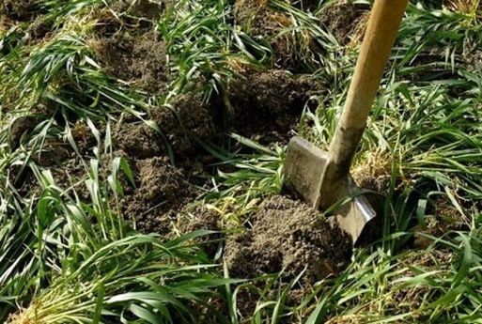
The Punjab agriculture department is promoting the cultivation of green manure these days as Punjab Agro is providing subsidy on the seed at the rate of Rs 2,000 per quintal, which costs Rs 6,300 per quintal without subsidy.

About:
- Green manures are crops grown specifically for maintaining soil fertility and structure.
- They are normally incorporated back into the soil, either directly, or after removal and composting.
- There are three main varieties of green manure, including Dhaincha, Cowpea, Sunhemp.
- Also some crops such as summer moong, mash pulses and guar act as green manure.
- Green manure varieties are incorporated into the soil when the crop is 42-56 days old.
- Green manure must be leguminous in nature, bear maximum nodules on its roots to fix large amount of atmospheric nitrogen in the soil.
- It helps in enhancing the organic matter in the soil, meets the deficiency of the micronutrients and reduces the consumption of the inorganic fertilisers etc.

PANDIT SHIVKUMAR SHARMA
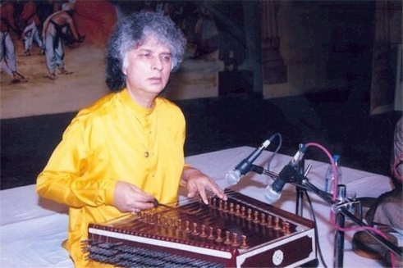
The Prime Minister Narendra Modi has expressed deep grief over the demise of noted Santoor maestro, Pandit Shivkumar Sharma.

About:
- Pandit Shivkumar Sharma (1938 – 2022) was an Indian classical musician and santoor player who is credited with adapting the santoor for Indian classical music.
- As a music composer he collaborated with Indian flutist Hariprasad Chaurasia under the name Shiv-Hari and composed music for many Indian films.
- Sharma was awarded the Sangeet Natak Akademi Award in 1986, the Padma Shri in 1991 and the Padma Bhushan in 2001.

PARAM VISHISHT SEVA MEDAL
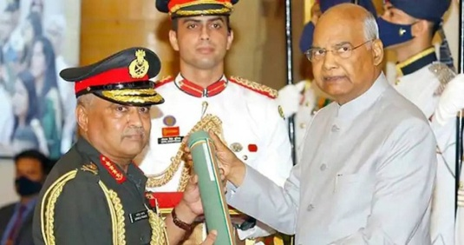
Army chief Gen Manoj Pande was given the Param Vishisht Seva Medal for distinguished service of exceptional order by President Ram Nath Kovind at a Defence investiture ceremony held at the Rashtrapati Bhavan.

About:
- Param Vishisht Seva Medal (PVSM) is a military award of India.
- It was constituted in 1960 and since then it is awarded in recognition to peace-time service of the most exceptional order and may be awarded posthumously.
- All ranks of the Indian Armed Forces including Territorial Army, Auxiliary and Reserve Forces, Nursing officers and other members of the Nursing services and other lawfully constituted Armed Forces are eligible for the award.
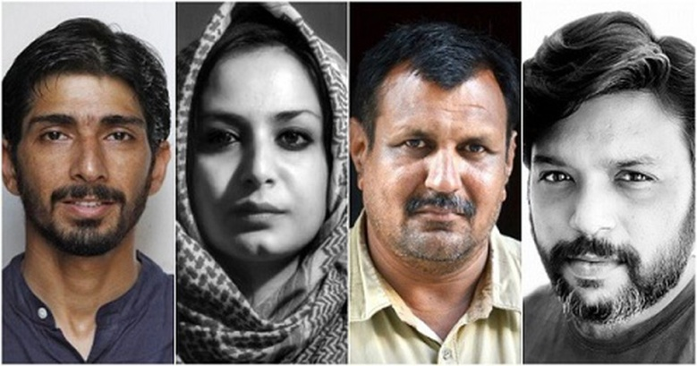
PULITZER PRIZE
A team of four Indian photographers from Reuters news agency — slain photojournalist Danish Siddiqui, Adnan Abidi, Sanna Irshad Mattoo and Amit Dave — have won the 2022 Pulitzer Prize for feature photography for their coverage of the Covid-19 crisis in India.

About:
- Arguably the most coveted award for journalists from across the world, the Pulitzer is announced by America’s Columbia University and bestowed on the recommendation of the Pulitzer Prize Board.
- The Pulitzer Prize is an award for achievements in newspaper, magazine, online journalism, literature and musical composition within the United States.
- It was established in 1917 by provisions in the will of Joseph Pulitzer.
- Prizes are awarded yearly in twenty-one categories.
Indians who have previously won the Pulitzer
- A member of the Ghadar Party in America, Indian-American journalist Gobind Behari Lal, was the first from India to win the Pulitzer Prize for journalism in 1937. He won the award for reporting with four others, for their coverage of science at the tercentenary of Harvard University.
- In 2000, London-born Indian-American writer Jhumpa Lahiri won the Pulitzer Prize in Fiction for her debut short story collection Interpreter of Maladies.
- In 2011, Siddhartha Mukherjee (Indian-American physician, biologist and author) won the Pulitzer Prize for General Non-Fiction for his demystification of cancer in The Emperor of All Maladies: A Biography of Cancer.

YOUTH IN INDIA
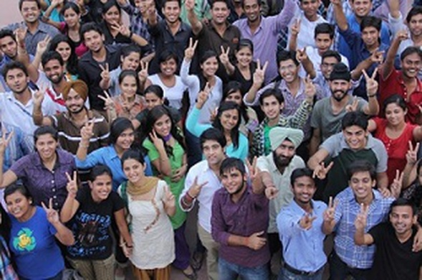
India’s population remains young, with more than one-fourth aged under 15 years and less than an eighth over 60.

About:
- There has been only a slight dip in the young population’s share in the last five years.
- Between the National Family Health Survey-4 (2015-16) and NFHS-5 (2019-21), the under-15 population has declined by 2 percentage points, from 29% to 27%, while the over-60 population has increased by as many points, from 10% to 12%.
- Over half the population (52%) is below 30, compared to 55.5% in NFHS-4.
- The NFHS divides the population into 5-year age groups from 0-4 years to 75-79, while those over 80 are counted in a single age group.
- The age pyramid shows India’s population is young, which is typical of developing countries with low life expectancy.
- The pyramid also shows that the average household size has decreased slightly between 2015-16 and 2019-21 (from 4.6 persons to 4.4).
- Just over one-sixth of households (18%) have female heads, up from 15% in NFHS-4.

MARTAND SUN TEMPLE
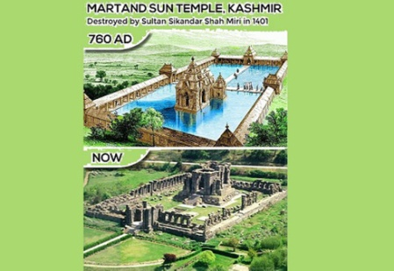
After prayers were held at the ruins of the eighth-century Martand Sun Temple in Jammu and Kashmir’s Anantnag last week, the Archaeological Survey of India (ASI) has expressed its concern to the district administration while refraining from lodging a formal complaint.

About:
- The ASI, which functions under the Ministry of Culture, is the custodian of the protected monument.
- According to ASI officials, prayers are allowed at its protected sites only if they were “functioning places of worship” at the time it took charge of them. No religious rituals can be conducted at non-living monuments where there has been no continuity of worship when it became an ASI-protected site.
- Although the Martand Sun Temple was once a thriving place of worship, commissioned by Lalitaditya Muktapida in the eighth century, it was destroyed by Sikandar Shah Miri in the 14th century.

